

Research into small business employment of mature age workers

**Final Report: Appendices**

Department of Employment and Workplace Relations

23 May 2023

Contents

Appendix 1: Project methodology 3

Appendix 2: Literature review 6

Appendix 3: Small business summaries 24

Appendix 4: Interventions 40

Appendix 5: Baseline and final surveys 57

Appendix 6: Baseline and final interview guides 70



Research into small business employment of mature age workers

**Appendix 1**

**Project methodology**

Overview

The project methodology comprises 4 stages that are summarised in Figure 1.

Stage 1. Planning and preparation
Inception meeting, project plan, literature review, recruitment of employers, development of data collection instruments
Stage 2. Fieldwork
Baseline data collection - survey and interviews, preliminary analysis and shortlist interventions, full analysis, presentation and interim report, development of resources and interventions, implement interventions, final data collection with employers
Stage 3. Gain expert input
Interviews and focus group with employment facilitators, synthesis of data and development of propositions, Delphi process with experts
Stage 4. Reporting
Prepare draft and final reports, presentations to Department and Collaborative Partnership

*Figure 1: Methodology summary*

Stage 1: Project planning and preparation

The first stage of the project was used to establish a sound basis for the research, and effective mechanisms for the project team to work with the Department and the participating small businesses. This stage comprised:

* **Inception meeting** with the Department to confirm the scope of the project; identify data sources and opportunities for recruiting small businesses; understand stakeholder expectations, risks and sensitivities; establish working relationships with the Department; and determine how best to present research findings.
* **Project plan**, and participant recruitment strategy, developed and submitted for Department approval.
* **Literature review** of national and international peer-reviewed and grey literature about organisation behaviour in relation to the employment of mature age workers.
* **Participant recruitment** leveraging Department networks, industry associations and support from members of the Collaborative Partnership to identify and secure potential small business participants from 3 industries – the wholesale and retail, hospitality and care services industries – and a mix of regional and urban locations.
* **Development of tools** to collect baseline data from participating businesses. These included a short online survey and an initial interview guide designed to gather consistent and reliable data on current behaviour across a range of dimensions.

Stage 2: Field work

Stage 2 included the following activities:

* **Baseline data** was gathered from participating businesses using a short online survey and a semi-structured interview tailored to pick up on issues raised in the survey. The collected data was used to establish a baseline of policies, practices and attitudes in each business – these are provided in Appendix 2.
* **Preliminary analysis** of survey and interview data was used to identify emerging themes and design a shortlist of interventions that could be implemented and trialled during the project. The shortlist of interventions was presented to the Department for approval.
* **Full analysis** of the data was conducted to understand similarities and differences in terms of policies, practices and attitudes and to identify what awareness raising interventions could most successfully be implemented as part of the project.
* **Development of interim report** based on the analysis above
* **Development of resources and interventions** in response to literature review and baseline data
* **Implementation of interventions** by disseminating resources to the participating businesses and working with them to ensure they engage with the resources
* **Final data collection** through a short online survey and semi-structured interview with the participating businesses. Data will also be collected from any Employment Facilitators who work with the businesses during the trial period.

Stage 3: Gain expert input

In the third stage of the project, the project team sought expert input on the findings, firstly through interviews and a focus group with the Employment Facilitators who were involved in the project.

The team then synthesised and analysed the data collected. Findings from the analysis were translated into themes and questions to test with key stakeholders such as members of the Collaborative Partnership on Mature Age Employment, other experts and senior departmental staff through a Delphi process.

The Delphi process aimed to strengthen the outcomes of the work by providing a collaborative and engaging process for experts to reflect on and interrogate both the implications and opportunities arising from the research findings.

Stage 4: Reporting

In the final stage of the project, the project team prepared a draft report summarising interview and intervention outcomes, drawing on the sensemaking process undertaken via the Delphi process. The draft report included recommendations for improvements to the intervention/s tested in order to achieve best practice. The draft report was presented to the Department and key stakeholders, and finalised following their feedback.

# 

Research into small business employment of older workers

**Appendix 2**

**Literature Review**

Department of Education, Skills and Employment

May 2022

Introduction

This literature review has been undertaken to provide a theoretical foundation upon which to design and implement the *Research into small business employment of older workers* project. It is not intended to be a comprehensive literature review. It is a broad scan of national and international research, predominantly from the last decade, to gather insights into organisations’ behaviour in relation to the employment of mature age workers, and where possible, insights into the particular behaviour, characteristics of and challenges facing small businesses.

Methodology

A total of 32 articles and reports were reviewed (see Attachment A). They were identified through:

* a previous literature scan conducted for the *Research into employment barriers for mature age Australians* project
* a google scholar search using search terms of small business/firms/enterprises, mature age workers, older workers, employment, recruitment, and age management
* a specific search of the journals, *Ageing and Society* and *Work, Aging and Retirement,* using the search terms described above.

A number of tools and resources were also reviewed for potential applicability to the project.

Key insights from the literature

The following insights, drawn from the reviewed literature, will inform development of the survey and interview questions and the design of interventions to be trialled through the project.

* ‘Older’ is a concept related to how people think or feel, rather than a chronological age
* Mature age workers are a highly diverse group and employers and managers tend to think in terms of individuals rather than a specific cohort. Therefore, diverse age management strategies are needed to support mature age workers
* Leading organisations tend to use an ‘age-neutral’ approach that supports flexibility, learning and well-being of all workers, regardless of age
* Stereotypes around older workers still need to be challenged, but perhaps through normalisation of mature age employment, rather than specific ‘myth busting’, which may unintentionally lead to an over-emphasis on age related differences
* Efforts to increase the sustainable employment of workers as they age need to avoid reinforcing negative stereotypes of older workers and inadvertent discrimination against younger people
* The business case for employing older workers seems to be less effective in influencing behaviour than support for the implementation of age management practices
* In small businesses, age management practices tend to be individualised and ad hoc, rather than based on policy and strategy. The literature seems to indicate that this flexible and tailored approach is an effective one (and may actually be of use in larger organisations)
* There is a need for resources and good practice examples tailored specifically to small business (and recognition of the specific challenges faced by small businesses, such as lack of time, financial and human resources, lack of specialist HR expertise and knowledge, and lack of awareness of available supports)
* Small businesses’ preferred strategies for supporting the employment and retention of mature age workers include subsidised training, financial incentives, support from the recruitment agencies, tailored advice and success stories.

What is a mature age worker?

The concept of a mature age worker is a nebulous one. The ABS has used a definition of those aged 45+ and many of the programs offered by the Australian Government are eligible for those aged 45+. The OECD uses the age group of 54-65.

Across the mature age worker literature reviewed for this report, the age group of focus ranged from 50+ to 55+ or 55-64. There is also a body of literature specifically focused on workers who are past normal retirement age (which varies across countries and across age cohorts).

The 2021 AHRI survey found that the largest group of respondents (28%) classify 61-65 as the age where someone becomes an older worker (see Figure 1). However, HR practitioners and experts are classifying ‘older workers’ as younger over time, even though the Australian workforce is aging.[1]

**Figure 1. Perceptions of the age at which someone is an ‘older worker’**

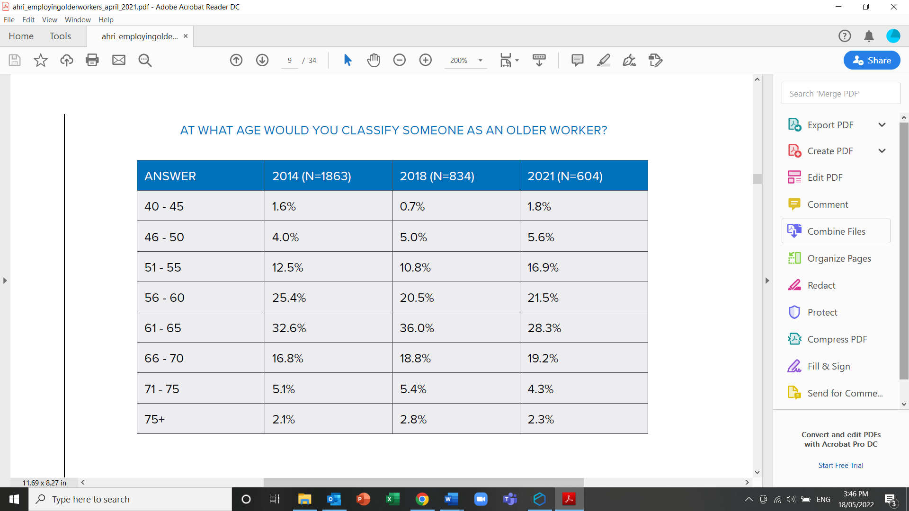

Source: Australian HR Institute (2021) *Employing and retaining older workers*

Previous research into employers’ willingness and ability to employ mature age workers adopted 55+ as its definition of mature age, as in Australia it is people in the 55-64 age group that most commonly report age discrimination.[2]

An important finding from the literature is that chronological age seems to be a less important factor in influencing decisions about the employment of mature age workers than the perceptions of decision-makers. Research undertaken in Scotland in 2016 found that older workers were defined more in terms of ‘feeling’ older or ‘thinking’ older rather than an individual’s chronological age. The researchers concluded that “the overriding message from the research that warrants most attention is that managers tend to think about employees in terms of the individuals rather than their age. The older workers expressed similar views. Thus, it can be argued that managers and older workers do not think about age and ageing in the workplace, as it is not seen to be a relevant issue, despite the demographic trends.”[3]

Many of the papers reviewed refer to the heterogeneity (i.e. diversity) of mature age workers. They stress that ‘one-size-fits-all’ approaches will not be effective in supporting people to remain in the workforce as they age. Instead, flexible, diverse approaches are needed, that reflect the diversity of older workers.[4] [5] [6]

What is age management?

Recent literature in relation to the employment and retention of mature age workers refers to good practice in terms of ‘age management’.

Age management can be defined as “those measures that combat age barriers and/or promote age diversity”,[7] as well as “maintaining the capability and willingness of workers to remain in work beyond ages at which they previously retired”.[8]

As such, age management practices can support workers at any age, as well as include practices focused more specifically on the retention of mature age workers.

The current state of employment of mature age workers

The literature suggests that in responding to ageing populations, governments from around the world are implementing policies and programs aimed at retaining mature age workers in the workforce for longer. However, these policy changes have not yet translated into widespread implementation of age management practices at the organisation level.[9] [10] [11] [12]

As an example, in Germany, the combination of demographic change and changes to pension and labour market policies has resulted in increased numbers of older employees. The proportion of people aged between 55 and 65 in the workforce has almost doubled in ten years and every fourth employee is aged 50+.[13] However, research shows that systematic age management practices are still the exception in German companies and there is a “knowing-doing gap” between the available information and the implementation of new practices by employers.[14]

In Australia, the workforce is also ageing. The 2021 AHRI survey found that for more than half of the respondents, workers aged 55+ make up more than 25% of their workforce, and for one in five respondents over half of their workforce is in this age group. This is a significant increase from previous years (see Figure 2).

**Figure 2. Proportions of workers over of the age of 55 in Australian workplaces**

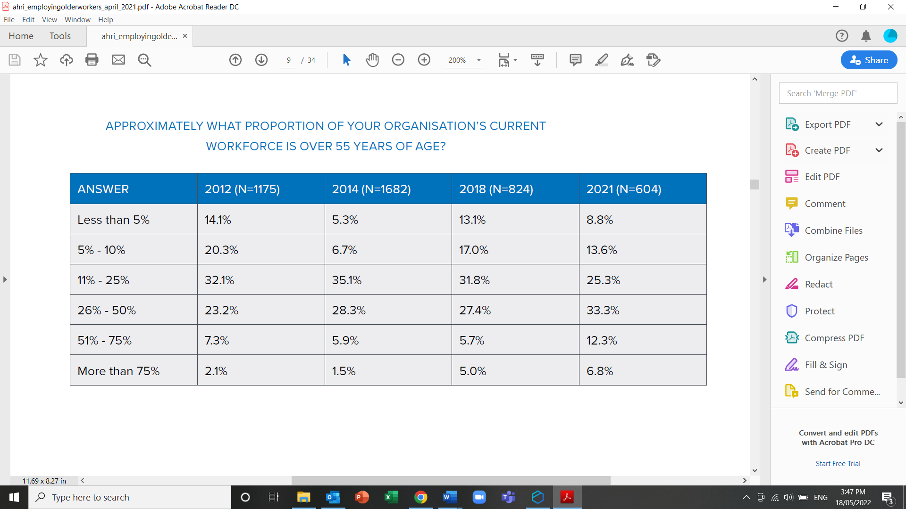

Source: Australian HR Institute (2021) *Employing and retaining older workers*

A 2016 review of Australian policy relating to older workers suggested that “in recent years the prospects of older workers in Australia appear to have improved markedly”.[15] The authors refer to the implementation of government policies and programs to support mature age workers’ participation in the workforce and changing attitudes amongst employers.

“There is tentative evidence that some employers may be turning to older workers in response to labour shortages, and it appears that significant proportions of employers anticipate an ageing of their workforces. This is suggestive of less need to convince employers of the merits of employing older workers, that is, overcoming supposed endemic ageism or the establishment of a business case, and greater need in terms of supporting the establishment of effective workplace ‘age management’.”

A 2021 study from the Netherlands has found that older workers are now being actively recruited for their readiness to work in part-time contracts and flexible hours, as well as for their life experience and people skills.

“Whereas 10 years ago, employers would be reluctant considering older candidates as valuable workforce, the experts stress that today the urgent need for employees makes that older candidates are no longer a blind spot, but, instead, become more attractive.”[16]

The assertion that the business case for employing mature age workers is not a strong motivator for changed practice is echoed elsewhere in the literature.

“… the research base has consistently demonstrated that organisations are failing to prepare and benefit from demographic and labour market changes, and that the business case approach to support the extension of working lives has not had the impact envisaged.”[17]

A piece of 2016 research into the use of flexible work arrangements in the UK found that in small businesses there was little recognition of the business case for employing older workers and a lack of strategy and policy around age management. Instead, individual older workers were recruited or retained on the basis of the owner-manager’s approach to “looking after certain valued workers as they aged”.[18]

The 2021 AHRI survey found that 23% of respondents reported that their organisation undertakes no recruitment practices to encourage an age diverse workforce, and 8.2% reported that their organisation offers none of the listed options that may help to support and retain late career employees. It is not possible to tell from the survey data however, which respondents are from small businesses with 20 or fewer employees, yet it is clear from the literature that practices in small businesses vary significantly from those in medium and large businesses.

# How are small businesses different from larger ones?

Whilst most of the literature reviewed relates to employment of mature age workers more broadly, many of the studies and reports reviewed refer to particular characteristics of small businesses that impact upon their ability to employ and retain mature age workers.

The literature suggests that small businesses are less likely to implement age management strategies than their larger counterparts.[19] [20] For example, a study that analysed 2011 data on the use of older worker-related human resources (HR) measures by German firms found that almost all large-sized companies with 500 and more employees had implemented at least one age-related HR instrument (e.g. training for older employees, adjustment of work requirements, activities for health promotion or partial retirement). However, only one out of ten small enterprises (less than 20 employees) had done so. The study further found that those small enterprises that did implement older-worker related HR measures were more likely to recruit older workers, rather than implement age-specific HR instruments.[21]

A 2013 study from the UK, found that while good practice in age management could be seen in small and medium enterprises, it was not part of a systematic strategy. [22]

Another UK study from 2016 found that in addition to a lack of strategy and policy, smaller firms have a low awareness of changing demographic patterns and their labour market impact, and limited recognition of the business case for older worker employment and flexible working arrangements.[23]

A 2022 study from the Netherlands found that small organisations were less likely to employ workers beyond the ‘normal retirement age’ than those that are medium and large.[24]

The reason for the lack of implementation of age management measures amongst small businesses is attributed to smaller organisations experiencing greater time and resource constraints than their larger counterparts, and to having less strategic and more reactive approaches to business operations, a lack of HR specialists and formal HR policies, and fewer opportunities for flexible working arrangements.[25] [26] [27] [28]

“The Inquiry was also told that small businesses can be time-poor and have limited access to information, however, the Inquiry found that some of the most innovative approaches came from small business.”[29]

A further challenge for small businesses is a lack of resources to seek advice regarding age management and a lack of guidance material and examples of good practice tailored specifically to small businesses. [30] [31]

“There are a number of guides and examples of good practice with regard to age management… However, good practice examples cited in these guides are often those adopted by large hospitality, utilities and retail chains/organisations. Therefore they may have only partial relevance to SMEs and SMEs could find it difficult to relate to them.”[32]

“The study found that a lack of good practice examples from SMEs can make it difficult for similarly sized companies to see the relevance or applicability of age management; managers, or staff, can feel inhibited in their ability to replicate such good practice examples, where there are clearly differing structures in place, or reduced resources available, in their own organisation. There is a need to develop good practice examples of age management policies and practices in SMEs, and to do so with a sectoral focus.”[33]

“In particular, there is still room for improvement in sharing information on good practices and tools designed to support the development of age-management strategies. However, general guidelines for age management have their limitations because of the heterogeneity of older workers as well as the more limited strategic human resources management capacities of SMEs. Guidelines and specialist help should, therefore, to take into account the different management styles and conditions of companies of different size.”[34]

Small businesses are also less likely to engage in formal training of employees (an important factor in the retention of mature age workers) due to barriers such as the cost and business disruption caused by staff attending training, a lack of understanding of the need and value of training, lack of HR expertise and fear that staff will leave the organisation after training.[35] Instead, training in small businesses tends to be informal, reactive, focused on the short-term, ‘on-the-job’ (rather than external training) and focused on the development of specific skills and organisational knowledge. [36]

# Influences on recruitment and retention of mature age workers

There is some interesting debate in the literature on attitudes towards mature age workers, which impact on their recruitment and retention. Many reports reference barriers to the recruitment of older workers that include:

* **Perceptions** – such as, that older workers are less productive, lack initiative, are resistant to change, are more likely to be injured or have increased absenteeism due to illness, are more expensive to employ, find it harder to learn/have decreased cognitive ability, are less competent and confident with technology, are less willing to engage in training and career development[37] [38] [39]
* **Skills and attributes** – such as, that older workers lack current skills, qualifications or experience (esp. technology skills), are over-qualified, have poor application/interview skills, cannot meet the physical demands of the work, have salary expectations that too high, are not the right cultural fit [40] [41]

However, other studies report that there is no evidence to support these claims.[42] [43] [44]

“It is frequently claimed that negative stereotypes of older workers play an important role in age discrimination in the workplace. The available evidence does not support this claim. Age-related differences in employment outcomes are often small, and important decisions about individuals (e.g., hiring, evaluations of performance, promotion decisions) are often made in contexts where decision-makers have access to great deal of information about the individuals, making it less likely that they will rely on group stereotypes.”[45]

“Where there is a loss of productivity among older workers, this may be due to skills obsolescence rather than age… suggesting that training for older workers is important. When older workers express less need for learning it may be because of their competence requirements rather than a decline in motivation to learn… or because they are less likely to be offered training or access to jobs that offer opportunities for training and progression.”[46]

A recent Australian paper reports that age discrimination against older workers is actually low and declining, and that reports of perceived age discrimination by individuals may be discouraging older workers from continuing to participate in the workforce. The report asserts that age stereotypes (both negative and positive) should be avoided in public discourse as they can unintentionally reinforce negative perceptions amongst employers or discriminate against younger workers.

“…in performance terms, a person’s age may not matter much for their ability to undertake most jobs. This suggests that instead of drawing on ageist stereotypes in making the case for older workers’ employment, their advocates might avoid confirmation bias among employers by arguing that, for most practical purposes, age and performance show little useful relationship. This would overcome the problem advocates face of potentially being accused of ageism, and consequently of muddling the public discourse… A more effective approach may be constructed on a foundation of age neutrality that seeks to cast doubt on the relevance of age for most employment decisions as opposed to questionable arguments for older workers’ superior performance.”[47]

A study of six Scottish workplaces (including SMEs and microenterprises), which was based on interviews with managers and older workers, concluded that it is individuals, not age, that is the determining factor in the employment of older workers.

“Arguably, the overriding message from the research that warrants most attention is that managers tend to think about employees in terms of the individuals rather than their age. The older workers expressed similar views. Thus, it can be argued that managers and older workers do not think about age and ageing in the workplace, as it is not seen to be a relevant issue, despite the demographic trends.”[48]

The same study however, noted a tension between “adopting a subjective view of age and ageing [which] presents opportunities for responsive and tailored support for employees” and “not considering the implications of age and ageing on the workplace [which] may mean that support is not put in place to support workers as they get older”.[49]

Another study from the United Kingdom found that high quality intergenerational contact (for example, through voluntary mentoring programs between younger and older workers) positively influences decision-makers willingness to hire older workers. It also found that decisions are influenced more by affective reactions to older people (e.g. feeling uncomfortable with interacting with older people due to stereotypes or previous negative experiences), than by perceptions of older workers’ competence.[50]

Whilst obvious discrimination against mature age workers appeared to be minimal in the literature reviewed, several studies suggest that stereotypes of older workers continue to exist and influence the behaviour of those with managerial and/or recruitment responsibilities.[51] [52]

“…while there was little reported direct discrimination against older workers, their enthusiasm… IT competencies… energy and physical capability… were nevertheless questioned. This suggests that stereotypes still influence attitudes and behaviours and therefore seems to support findings from other research showing a gap between non-age discriminatory policies and actual practice”[53]

A study focusing on job advertisements targeting older workers in the Netherlands found that stereotypes persist in recruitment processes. They reinforce the idea that older workers have good ‘soft’ abilities (e.g. loyalty, reliability, communication), but poorer ‘hard’ abilities (especially digital skills, up-to-date knowledge and physical capabilities). Although strengths in soft abilities are valued by employers who are looking for a “social and responsible workforce”, the authors recommend that organisations educate themselves about older workers actual abilities and aspirations to “prevent thinking and acting in terms of the general stereotype of older adults as being warm but incompetent.” They suggest creating communication tools that promote more realistic messaging about older workers.

“The more often older workers are portrayed in a variety of work settings and jobs, including working in flexible contracts and in irregular working hours, the more often older candidates will be considered regular workforce, and the more is taken into account to protect their sustainable employability. The communication tool could provide guidance to managers in emphasizing realistic communication about older workers’ abilities, by making visible their normality as well as their successes, and endorsing them as role models to other (older) employees. This can be done during everyday informal encounters at the work floor, by means of meetings, training programs, and personnel projects, but also by means of increasing their visibility in formal corporate communication outlets, and by hiring them in case of vacancies. This could eventually also help employees to distance themselves from the older workers’ stereotype.”[54]

Lack of knowledge and skills in relation to age management, including the recruitment and retention of mature age workers, is a continuing theme within the literature, with several reports also noting a gap between knowledge and practice.[55] [56] [57]

“In spite of the well-documented benefits of age-management strategies, the level of implementation of these strategies varies greatly between OECD countries and the “knowing-doing gap” remains large. In particular, implementation of age-management strategies in SMEs remains weak.”[58]

“It also seems to be important to improve the information of companies concerning best practice projects or funding opportunities and hence help to reduce implementation problems.”[59]

The 2016 National Inquiry into Employment Discrimination Against Older Australians and Australians with Disability found a lack of knowledge amongst employers, and particularly small businesses about government programs and initiatives that might assist them with employing older workers. The inquiry noted a low uptake of the Restart wage subsidy and reports that many individuals and even some employment service providers were unaware of the program.[60]

The inquiry also noted a range of particular challenges experienced by small businesses, including:

* Lack of knowledge and experience in working with older people
* Lack of confidence and capacity to have conversations with potential and existing older employees
* Lack of awareness of available support and financial resources
* Insufficient flexibility to offer flexible work arrangements and transition to retirement arrangements
* Lack of specialist HR expertise and lack of time to educate themselves on diversity.

# Age management practices

Age management practices can include adaptations related to job recruitment, learning, training, and life-long learning, career development, flexible working practices, health protection/promotion and workplace design, redeployment as well as employment exit and transition to retirement.[61] Some organisations also seek to retain older workers through team work and collaboration programmes, which both enable continuous learning and support knowledge transfer.[62] [63]

Many of the reviewed studies and reports refer to the need for a range and diversity of age management practices to meet the needs of diverse organisations and the diversity of mature age workers.[64] [65] [66] [67] [68]

An action research project conducted with 31 organisations in Italy and Spain to design and implement age management strategies concluded that “the variety of actions and the different strategies developed and implemented by the organisations that took part in the project demonstrate that AM [age management] cannot be conceived as a single answer to diversified needs.”[69] The project found that the availability of economic and time resources and the organisational culture had a major impact on the successful implementation of age management strategies.

A survey of the HR practices used by organisations in the Netherlands to increase sustainable employment of their workforce, found that implementation of a larger number of the HR practices of focus was positively related to higher satisfaction with the current employability of employees, and to increased productivity of the organization. The study noted that due to financial and human resource constraints, small organisations may need to focus on a more limited set of practices. However, they found that small organisations reported more implemented practices, more participation of employees, and a stronger health culture than large organisations, as well as higher effectiveness of the HR practices in improving sustainable employment, and higher satisfaction with current employability of employees. The authors suggest that this may be attributed to small business owners having more direct contact with their personnel, and as a result investing only in HR practices that are really wanted and necessary, which may be more effective that the standardised practices offered by large organisations. [70]

A 2013 study of age management in SMEs in the UK found that the provision of generic and tailored brochures on the case for an age diverse workforce and good practice in age management, along with a two-hour age management workshop for managers and HR personnel, resulted in a number of changes amongst participating SMEs. Following the awareness raising activities, two of the six SMEs had changed or intended to change aspects of their recruitment practices and all but one manager reported that they would consider participating in age management training or seeking guidance on age management in the future.[71]

The awareness raising activities in the UK study did not result in any change in implementation of flexible work arrangements as they were already dealt with on a case-by-case basis wherever possible. A specific study of flexible working arrangements (FWAs) in smaller firms in the UK also found that flexible work options were rarely offered in a strategic or policy-based way. They were typically offered in a reactive, ad hoc way, at the prerogative of the manager, and for the purpose of ‘looking after’ valued older workers or recruiting needed skills and experience. The study argues that “idiosyncratic, individualised approaches allow smaller firms to deliver FWAs in beneficial ways, reinforcing their contribution to productive ageing… and extending working lives. FWAs, thus, constitute part of the minimum set of HR practices required for smaller firm success.” [72]

A 2017 US-based study of organisational responses to an ageing workforce found that the most successful organisations were those that were disrupting traditional mindsets about work, careers and retirement.[73] The study found that innovative organisations are leading change by developing policies and practices that are applicable to employees of all ages and which provide all employees with opportunities for greater flexibility, scaling back of time commitments and access to training.

“We find the new logics to be organized around age-neutral more than age-related norms and assumptions, with uniform reluctance to separate out older workers for special policies.”[74]

Innovative organisations identified by the study (which included small businesses) are using new technologies to redesign jobs to be less physically difficult and to allow for teleworking and greater flexibility of work hours. Some organisations are allowing employees to scale back their work and some are creating new labour pools by hiring (or re-hiring) retirees in new roles with fewer hours. The study also found that 70% of the leading organisations they examined involve older workers in training and professional development as part of normal practice.

Outpost Consulting’s previous research into employment barriers for mature age Australians found that employment of mature age workers was considered less important to the reputations of small businesses than to medium and large organisations, and that small businesses found it much more difficult to find and retain mature age workers than those that were medium and large. The research concluded that:

* Organisations of all sizes could benefit from initiatives that help to make the employment of mature age workers more of a social norm, and even more so for small businesses. Initiatives that increase the incentive or highlight the benefits of employing mature age workers could also help to make it more of a social norm.
* Organisations of all sizes could benefit from initiatives that increase the opportunity to employ and retain mature age workers by making it easier. Once again, this is particularly so for small businesses.
* Initiatives that help to build the knowledge and skills of organisations in recruiting and retaining mature age workers would also be of benefit across the board.[75]

The research also found that small organisations are most motivated by subsidised training and financial incentive, and are more interested in success stories or not motivated by any of the strategies, compared to other sized organisations. The top five preferred strategies of small businesses to help with recruiting and retaining mature age employees were:

1. Subsidised training
2. Financial incentives
3. Support from recruitment agencies
4. Tailored advice
5. Success stories.

# Resources

The literature review identified a number of resources related to employment of mature age workers that may be relevant to this project. However, cautions from the literature about many resources being unsuitable or irrelevant to small businesses should be noted, as should the finding that the business case for employing mature age worker is likely to have less impact that support for implementation of age management practices.

Australian Government Resources and Programs

* **Investing in Experience Tool Kit** – includes information on the business case, a self-assessment tool, information and checklists on recruitment and retention practices, and information about superannuation, retirement and safe workplaces (available through the Mature Age Hub - https://www.dewr.gov.au/mature-age-hub
* **Videos, brochure and poster** on the benefits of employing mature age workers (available at https://www.dewr.gov.au/mature-age-hub
* **Training for employers on employing mature age workers** – three online training modules on Busting myths, Is my workplace age inclusive?, and Building age inclusive workplaces available at https://www.dewr.gov.au/mature-age-hub
* **Restart wage subsidy** – available through employment services providers (N.B. administration of the subsidy will be changing with the commencement of Workforce Australia on 1 July 2022)
* **Skills and training incentive** - available through the Skills Checkpoint for Older Workers program (see <https://skillscheck.com.au/>)
* **Australian Human Rights Commission** – has a series of resources on its Older Workers Resource Hub, including online training, a webinar, guides and factsheets (see <https://humanrights.gov.au/olderworkers>)
* [**www.business.gov.au**](http://www.business.gov.au) – includes a wide range of resources for businesses, including on topics such as recruitment, diversity and managing flexible working, as well as a searchable list of business advice services (some of which are free) <https://business.gov.au/people/employees/equal-opportunity-and-diversity>

International tools and resources

* **Later Life Workplace Index (LLWI)** – a self-assessment tool for businesses, which examines nine dimensions related to the employment of age diverse and older workforces (further information available at <https://matureworkers.cepar.edu.au/p/nine-dimensions-of-the-later-life-workplace-index-llwi/> )
* **UK Department of Work and Pensions, Employer case studies: Employing older workers for an effective multi-generational workforce** – a collection of 32 case studies from a range of industries and public and private employers on approaches to employing older workers (available online at <https://assets.publishing.service.gov.uk/government/uploads/system/uploads/attachment_data/file/754151/employing-older-workers-case-studies.pdf> N.B. This is a 2011 document that has now been withdrawn from publication as it is no longer current)

# Attachment A. List of reviewed literature

Arman, R., Kadefors, R., & Wikström, E. (2021). ‘We don't talk about age’: A study of human resources retirement narratives*.* *Ageing and Society*, *First View*, 1-27.

Atkinson, C. & Sandiford, P. (2016) An exploration of older worker flexible working arrangements in smaller firms**.** *Human Resource Management Journal*, 26, (1), 12–28.

Australian HR Institute (2021) *Employing and retaining older workers*. Australian HR Institute, Melbourne and Australian Human Rights Commission, Sydney.

Australian Human Rights Commission (2015) *National Prevalence Survey of Age Discrimination in the Workplace – 2015*. Australian Human Rights Commission, Sydney.

Australian Human Rights Commission (2016)*Willing to Work: National Inquiry into Employment Discrimination Against Older Australians and Australians with Disability.* Australian Human Rights Commission, Sydney.

Blomé, M., Borell, J., Håkansson, C. & Kerstin Nilsson (2020) Attitudes toward elderly workers and perceptions of integrated age management practices. *International Journal of Occupational Safety and Ergonomics*, 26 (1), 112-120.

Boehm, S., Schröder, H. & Bal, H. (2021) Age-Related Human Resource Management Policies and Practices: Antecedents, Outcomes, and Conceptualizations. *Work, Aging and Retirement*, 7 (4), 257–272.

Brussig, M. & Leber, U. (2019) After early retirement: the variety of human‑resource strategies of firmstowards older employees**.** *Journal for Labour Market Research*, 53:15

Bryson, A., Forth, J., Gray, H. & Stokes, L. (2020) Does Employing Older Workers Affect Workplace Performance? *Industrial Relations: A Journal of Economy and Society*, 59 (4), 532-562.

Egdell, V., Maclean, G., Raeside, R. & Chen, T. (2020) Age management in the workplace: manager and older worker accounts of policy andpractice. *Ageing and Society*, 40 (4), 784-804.

Fasbender, U. & Wang, M. (2017) Intergenerational contact and hiring decisions about older workers. *Frontiers in Psychology,* 7, 2057.

Fekke Ybema, J., van Vuuren, T. & van Dam, K. (2020) HR practices for enhancing sustainable employability: implementation, use, and outcomes. *The International Journal of Human Resource Management*, 31 (7), 886-907.

Fuertes, V., Egdell, V. & McQuaid, R. (2013), Extending working lives: age management in SMEs, *Employee Relations*, 35 (3), 272-293.

Garavaglia, E., Marcaletti, F. & Iñiguez-Berrozpe, T. (2021) Action Research in Age Management: The Quality of Ageing at Work Model, Work, Aging and Retirement, 7 (4), 339–351.

Hodgkin, S., Warburton, J., Savy, P. & Moore, M. (2017), Workforce Crisis in Residential Aged Care: Insights from Rural, Older Workers. *Australian Journal of Public Administration*, 76, 93-105.

Moen, P, Kojola E. and Schaefers, K. (2017) Organizational Change Around an Older Workforce. *Gerontologist*, 57 (5), 847–856.

Murphy, K. & DeNisi, A. (2021) Do Age Stereotypes Predict Personnel Decisions? The State of the Evidence, Work, Aging and Retirement, waab019 .

OECD (2019) *Working Better with Age: Overview.* OECD Publishing, Paris.

Outpost Consulting (2021) *Research into employment barriers for mature age Australians.* Published online at <https://www.dese.gov.au/mature-age-hub/resources/employment-barriers-mature-age-australians-research-project> .

Perry, E., Golom, F., Catenacci, L., Ingraham, M., Covais, E. & Molina, J. (2017) Talkin’ ‘Bout Your Generation: The Impact of Applicant Age and .Generation on Hiring-Related Perceptions and Outcomes. *Work, Aging and Retirement*, 3 (2), 186–199.

Peterson, R.T., & Stratemeyer, A.W. (1998) An analysis of small business hiring of seniors. *Journal of Small Business Strategy*, 9 (1).

Taneva, S.K., Arnold, J. & Nicolson, R. (2016) The Experience of Being an Older Worker in an Organization: A Qualitative Analysis**.** *Work, Aging and Retirement*, 2 (4), 396–414.

Taylor, P., & Earl, C. (2021). The enduring myth of endemic age discrimination in the Australian labour market. *Ageing and Society*, 1-10.

Taylor, P., Earl, C. & McLoughlin, C. (2016), Recent public policy and Australian older workers*. Australian Journal of Social Issues*, 51, 229-247.

The Age and Employment Network (TAEN) (2007), Managing the Ageing Workforce: An Introductory Guide to Age Management for HR Professionals, TAEN, London.

Trochimiuk, R. (2015) Professional Development of Older Employeesin Small and Medium Enterprises**.** *Management and Business Administration. Central Europe*, 23 (1), 79–94.

Tunney, O. & Mulders, J.O. (2022) When and Why Do Employers (Re)Hire Employees Beyond Normal Retirement Age? *Work, Aging and Retirement*, 8 (1), 25–37.

Urbancova, H. & Hudakova, M. (2015) Employee Development in Small and MediumEnterprises in the Light of Demographic Evolution. *Acta Universitatis Agriculturae et Silviculturae**Mendelianae Brunensis*, 63(3), 1043–1050.

van Selm, M. & van den Heijkant, L. (2021) In Search of the Older Worker: Framing Job Requirements in Recruitment Advertisements. *Work, Aging and Retirement*, 7 (4), 288–302.

Vigtel, T.C. (2018), The retirement age and the hiring of senior workers, *Labour Economics*, 51, (C), 247-270

Wilckens, M., Wöhrmann, A., Deller, J. & Wang, M. (2021) Organizational Practices for the Aging Workforce: Development and Validation of the Later Life Workplace Index. *Work, Aging and Retirement*, 7 (4), 352–386.

Zientara, P. (2009) Employment of older workers in Polish SMEs: employer attitudes and perceptions, employee motivations and expectations, *Human Resource Development International*, 12(2), 135-153.

# 

Research into small business employment of older workers

**Appendix 3**

**Summaries of small businesses**

**Participant: H1**

|  |  |  |
| --- | --- | --- |
| **Background** | **Age profile** | |
| |  |  | | --- | --- | | **Industry**  **Type of business** | Holiday apartments  Accommodation and food services | | **Location**  **Age of participant** | Regional NSW  25-44 years | | **Score - interest in MAW** | 5 (1 low: 10 high) | | Below 25 years  25-44  45-54  55-64  65 and over  **TOTAL** | 2  5  5  -  -  **12** |
| **Reasons for participating (survey)** | **Key Challenges (interview)** | |
| * I want to learn more about managing older workers * I need to recruit new employees | * Concerns about injury, everyone doing same amount of physical work. * MAW have good customer service skills, but not as confident with technology. * Where to find MAW? | |
| **Attitudes towards MAW (interview)** | **Views on MAW (survey) ✓agree 🗶 disagree --neutral** | |
| * Had problems with younger workers’ social lives and older workers being slower. * Now good balance, mix is right. | * Reliable ✓ * Loyal and committed ✓ * Less physically able ✓ * More likely to take sick days 🗶 * Less productive 🗶 * Great mentors -- * Don't adapt well to change -- * Struggle with digital technology ✓ * Have fewer accidents -- * Age doesn't matter -- | |
| **Recruitment practices (interview)** | **Age management practices (interview)** | |
| * Seek, social media, local tourism organisation, recruitment agencies, not Job Active. * Restart - supported training, extra hours. * Considering grey nomads, where to find? | * MAW appreciate above award wages and flexible hours more than younger. * Flexibility to fit workers’ needs. * Incentives, bonuses, team building, lunches. | |
| **Age management practices (survey)** |  | |
| * Flexible times/locations – support, not used yet * Part-time – used, or currently using * Job-redesign - do not support * Advertising free of age bias – support, not used yet * Health and wellbeing programs – support, not used yet | * Carers leave - used, or currently using * Phased retirement – support, not used yet * Training for all ages – used, or currently using * Employment of retirees – support, not used yet * Multi-age teams – support, not used yet * MAW mentor younger workers – support, not used yet | |

**Participant: H2**

|  |  |  |
| --- | --- | --- |
| **Background** | **Staff Profile** | |
| |  |  | | --- | --- | | **Industry** | Accommodation and Food Services | | **Location**  **Type of business** | Metropolitan SA  Catering | | **Score - interest in MAW** | 6 (1 low: 10 high) | | **Age of participant** | 65 and over | | **Below 25 years**  **25-44**  **45-54**  **55-64**  **65 and over**  **TOTAL** | 5  4  5  7  1  **22 (under 20 FTE)** |
| **Reasons for participating (survey)** | **Key Challenges (interview)** | |
| * Mature age people make good workers for our business * I want to contribute to research about the workforce * Assisting with worthwhile research | * Difficult to give steady income, because of irregular demand in catering. * Some don’t stay long if we can’t offer enough hours. * Some MAW limit hours so pension not impacted. * Hard to find other enticements to keep them. | |
| **Attitudes towards MAW (interview)** | **Views on MAW (survey) ✓agree 🗶 disagree --neutral** | |
| * Don’t want to be seen as oldest caterers in town. * Conscious of looking after and monitoring MAW, their safety. | * Reliable ✓✓ * Loyal and committed ✓✓ * Less physically able ✓ * More likely to take sick days 🗶 * Less productive 🗶 * Great mentors ✓ * Don't adapt well to change -- * Struggle with digital technology -- * Have fewer accidents -- * Age doesn't matter ✓ | |
| **Recruitment practices (interview)** | **Age management practices (interview)** | |
| * Word of mouth, friends of existing MAW. * Target semi-retired or retired topping up income, uni students. * MAW like short hours, flexibility, variation of hours. * Occasionally use Job Active, with no success. | * Supportive social networks created. * MAW mentoring and leading younger workers, makes them feel valued. * Build diversity in team, balanced with efficiency. | |
| **Age management views (survey)** |  | |
| * Flexible times/locations – support, not used yet * Part-time options – support, not used yet * Job-redesign – support, not used yet * Advertising free of age bias – support, not used yet * Health and wellbeing programs – used, or currently using | * Carers leave – support, not used yet * Phased retirement – support, not used yet * Training for all ages – support, not used yet * Employment of retirees – support, not used yet * Multi-age teams – used, or currently using * MAW mentor others – used, or currently using | |

**Participant: H3**

|  |  |  |
| --- | --- | --- |
| **Background** | **Staff Profile** | |
| |  |  | | --- | --- | | **Industry** | Accommodation and Food Services | | **Location**  **Type of business** | Regional VIC  Hotel | | **Score - interest in MAW** | 5 (1 low: 10 high) | | **Age of participant** | 45-54 years | | **Below 25 years**  **25-44**  **45-54**  **55-64**  **65 and over**  **TOTAL** | 15  7  2  -  -  **24 (under 20 FTE)** |
| **Reasons for participating (survey)** | **Key Challenges (interview)** | |
| * I need to recruit new employees | * Lots of help available, but where do you start? * MAW feel they won’t fit, aren’t wanted, so don’t apply. * MAW have other responsibilities, so work can be physically and mentally draining. | |
| **Attitudes towards MAW (interview)** | **Views on MAW (survey) ✓agree 🗶 disagree --neutral** | |
| * Can go both ways, MAW’s attitude is they aren’t wanted. * If they can do job, happy to employ them. * Younger people more likely to apply because of night and weekend work. * Don’t care about their age, team players are needed. | * Reliable ✓ * Loyal and committed ✓ * Less physically able -- * More likely to take sick days 🗶 * Less productive 🗶 * Make great mentors -- * Don't adapt well to change -- * Struggle with digital technology -- * Have fewer accidents -- * Age doesn't matter ✓✓ | |
| **Recruitment practices (interview)** | **Age management practices (interview)** | |
| * Seek, Facebook, government website * Don’t use newspaper, although older people read daily * Tried Job Actives recently, not much response. * AHA is helpful – IR issues, proforma job descriptions etc. | * Flexibility in shifts and hours. * Regular meetings with fulltime staff for development and mentoring. * Buddy system for new employees. * Got to be a good fit within team. | |
| **Age management views (survey)** |  | |
| * Flexible times/locations – used, or currently using * Part-time options - used or currently using * Job-redesign – used, or currently using * Advertising free of age bias – used, or currently using * Health and wellbeing programs - used or currently using | * Carers leave – support, not used yet * Phased retirement – support, not used yet * Training for all ages – used, or currently using * Employment of retirees – support, not used yet * Multi-age teams - used, or currently using * Mentor younger workers – used, or currently using | |

**Participant: H4**

|  |  |  |
| --- | --- | --- |
| **Background** | **Staff Profile** | |
| |  |  | | --- | --- | | **Industry** | Accommodation and food services | | **Location**  **Type of business** | Regional SA  Catering | | **Score - interest in MAW** | 7 (1 low: 10 high) | | **Age of participant** | 25-44 years | | **Below 25 years**  **25-44**  **45-54**  **55-64**  **65 and over**  **TOTAL** | 1  6  6  2  -  **15** |
| **Reasons for participating (survey)** | **Key Challenges (interview)** | |
| * I want to learn more about managing older workers * I need to recruit new employees * Mature age people make good workers for our business | * Applicants often aren’t suitable. * How do you find MAW? with the right skills? * Personal/family responsibilities can take precedence over work. * MAW struggle with technology. * Need more innovative solutions than Job Active providers. | |
| **Attitudes towards MAW (interview)** | **Views on MAW (survey) ✓agree 🗶 disagree --neutral** | |
| * MAW treated like Aunties, so a lot of respect. * They mentor younger workers- new skills on the job, routine of coming to work everyday, reliability. | * Reliable ✓✓ * Loyal and committed ✓✓ * Less physically able ✓ * More likely to take sick days -- * Less productive 🗶 * Make great mentors for younger employees ✓✓ * Don't adapt well to change -- * Struggle with digital technology ✓✓ * Have fewer accidents ✓ * Age doesn't matter ✓✓ | |
| **Recruitment practices (interview)** | **Age management practices (interview)** | |
| * Used Job Active to access funding - not always successful, screening not good. Same person often with several providers. * SEEK or local newspaper. * Subsidies – Restart, traineeships, and others. | * Vary their workload, only do parts of job few times a week. Careful about their health. Don’t do as much active work. * They’re hard workers, to keep them longer need to look after them. | |
| **Age management views (survey)** |  | |
| * Flexible times/ locations – used, or currently using * Part-time options – used, or currently using * Job-redesign – support, not used yet * Advertising free of age bias – used, or currently using * Health and wellbeing programs – support, not used yet | * Carers leave – used, or currently using * Phased retirement – support, not used yet * Training for all ages – used, or currently using * Employment of retirees – support, not used yet * Multi-age teams – used, or currently using * Mentor younger workers – used, or currently using | |

**Participant: H5**

|  |  |  |
| --- | --- | --- |
| **Background** | **Staff Profile** | |
| |  |  | | --- | --- | | **Industry** | Accommodation and Food Services | | **Location**  **Type of business** | Metropolitan NSW  Café Restaurant | | **Score - interest in MAW** | 5 (1 low: 10 high) | | **Age of participant** | 25-44 | | **Below 25 years**  **25-44**  **45-54**  **55-64**  **65 and over**  **TOTAL** | 4  2  1  -  7 |
| **Reasons for participating (survey)** | **Key Challenges (interview)** | |
| * I need to recruit new employees * I'm interested in getting tailored recruitment support from the government | * No shows for interviews, trials, no responses for resumes, no shows on first day, gone elsewhere with no communication. * MAW struggle with pace of work and IT. * Where to find MAW? Need a matching service. * Salary expectations might be higher? | |
| **Attitudes towards MAW (interview)** | **Views on MAW (survey) ✓agree 🗶 disagree --neutral** | |
| * Younger staff frustrated by limitations on MAW’s ability. | * Reliable ✓ * Loyal and committed ✓ * Less physically able ✓ * More likely to take sick days **--** * Less productive 🗶 * Make great mentors for younger employees ✓ * Don't adapt well to change ✓ * Struggle with digital technology ✓ * Have fewer accidents **--** * Age of the worker doesn't matter **--** | |
| **Recruitment practices (interview)** | **Age management practices (interview)** | |
| * Social media, Seek, recruitment agencies, agency chefs. * Agencies expensive, but better results. * Industry associations support HR issues, but not recruitment. | * Flexible rostering. * Dividing full time role into two part-time. | |
| **Age management views (survey)** |  | |
| * Flexible times/locations - do not support * Part-time options – support, not used yet * Job-redesign - do not support * Recruitment free of age bias - support, not used yet * Health and wellbeing programs – support, not used yet | * Carers leave - do not support * Phased retirement – support, not used yet * Training for all ages – support, not used yet * Employment of retirees – support, not used yet * Multi-age work teams – support, not used yet * MAW mentor others – support, not used yet | |

**Participant: W&R1**

|  |  |  |
| --- | --- | --- |
| **Background** | **Staff Profile** | |
| |  |  | | --- | --- | | **Industry** | Retail /Wholesale | | **Location**  **Type of business** | Regional VIC  Retail gift shop | | **Score - interest in MAW** | 5 (1 low: 10 high) | | **Age of participant** | 55-64 years | | **Below 25 years**  **25-44**  **45-54**  **55-64**  **65 and over**  **TOTAL** | 2  -  1  -  -  **3** |
| **Reasons for participating (survey)** | **Key Challenges (interview)** | |
| * Mature age people make good workers for our business * I'm interested in getting tailored recruitment support from the government * I like participating in research | * Employing people is hard in a small town. * In a very small business, you leave them in control, big responsibility. * Put in a lot of effort, then find people aren’t suitable. * Housing and transport problems in regions. | |
| **Attitudes towards MAW (interview)** | **Views on MAW (survey) ✓agree 🗶 disagree --neutral** | |
| * Life experience brings better skills. * Can be problematic having younger people telling older people what to do. * Personality matters more than age. * People in regions might have less bias against aged than in cities. | * Reliable ✓✓ * Loyal and committed ✓✓ * Less physically able ✓ * More likely to take sick days 🗶 * Less productive 🗶 * Make great mentors ✓ * Don't adapt well to change ✓ * Struggle with digital technology ✓ * Have fewer accidents -- * Age doesn't matter ✓ | |
| **Recruitment practices (interview)** | **Age management practices (interview)** | |
| * Word of mouth, shop window. * Recruitment agency, but awful experience, wasn’t listened to, gave me inappropriate people. * SEEK – disaster, most people satisfying Centrelink needs. * Restart – had to work 3 days/week. Good trial. * Advertise for juniors with job description. | * Normally age diversity works really well. * Need wholistic approach, not piecemeal solutions. * Interested in supporting workers towards retirement. | |
| **Age management views (survey)** |  | |
| * Flexible times/locations – used, or currently using * Part-time options – support, not used yet * Job-re-design - used, or currently using * Advertising free from age bias – support, not used yet * Health/wellbeing programs – support, not used yet | * Carers leave – support, not used yet * Phased retirement – support, not used yet * Training for all ages – support, not used yet * Employment of retirees – support, not used yet * Multi-age teams – support, not used yet * MAW mentor others – used, or currently using | |

**Participant: W&R2**

|  |  |  |
| --- | --- | --- |
| **Background** | **Staff Profile** | |
| |  |  | | --- | --- | | **Industry** | Retail/wholesale | | **Location**  **Type of business** | Regional NSW  Retail shoe shop | | **Score - interest in MAW** | 5 (1 low: 10 high) | | **Age of participant** | 65 years and over | | **Below 25 years**  **25-44**  **45-54**  **55-64**  **65 and over**  **TOTAL** | -  -  -  1 (FTE, 2 part-time)  -  **1** |
| **Reasons for participating (survey)** | **Key Challenges (interview)** | |
| * I need to recruit new employees * Mature age people make good workers for our business | * Finding replacement/s so owner can step back. * Subsidies aren’t easy to access. * Older people can lack confidence in technology. * People looking for loopholes (super, pensions, tax, penalty rates) make it hard for employers. | |
| **Attitudes towards MAW (interview)** | **Views on MAW (survey) ✓agree 🗶 disagree --neutral** | |
| * Younger people can bring more risks. * Personality is more important than age. * Can work through any differences of views. * Need to consider people’s preferences re family or personal responsibilities. * Older people can be less patient. * Older people have more skills, need less training than younger ones. * Older staff reflect customer base. | * Reliable ✓ * Loyal and committed -- * Less physically able -- * More likely to take sick days 🗶 * Less productive 🗶 * Make great mentors ✓ * Don't adapt well to change -- * Struggle with digital technology 🗶 * Have fewer accidents 🗶 * Age doesn't matter ✓✓ | |
| **Recruitment practices (interview)** | **Age management practices (interview)** | |
| * Word of mouth works in small town. * Customers can be suitable to recruit. * If advertising, use Facebook. * No success with Job Active providers. * Subsidies hard to get, sometimes not worth it. * Trial people for few days. | * Many older people don’t want 38 hours. * Need to be flexible for all employees, about relationships. * Check physical environment – stairs, light. * Allow individuals to make choices. * Follow (employment) rules and employee’s wishes. | |
| **Age management views (survey)** |  | |
| * Flexible times/locations – used, or currently using * Part-time work options – used, or currently using * Job-redesign – used, or currently using * Advertising free of age bias - used, or currently using * Health and wellbeing programs – support, not used yet | * Carers leave - used, or currently using * Phased retirement – support, not used yet * Training for all ages – support, not used yet * Employment of retirees – support, not used yet * Multi-age teams – support, not used yet * MAW mentor other workers – support, not used yet | |

**Participant: W&R3**

|  |  |  |
| --- | --- | --- |
| **Background** | **Staff Profile** | |
| |  |  | | --- | --- | | **Industry** | Retail /Wholesale | | **Location**  **Type of business** | Metropolitan NSW  Wholesaler | | **Score - interest in MAW** | 8 (1 low: 10 high) | | **Age of participant** | 45-55 years | | **Below 25 years**  **25-44**  **45-54**  **55-64**  **65 and over**  **TOTAL** | -  1  3  1  2  **7** |
| **Reasons for participating (survey)** | **Key Challenges (interview)** | |
| * I need to recruit new employees * Mature age people make good workers for our business * I'm interested in getting tailored recruitment support from the government * Gift Card is a good incentive | * Finding suitable applicants * Targeting MAW without being discriminatory | |
| **Attitudes towards MAW (interview)** | **Views on MAW (survey) ✓agree 🗶 disagree --neutral** | |
| * Most of workforce is older, until recently youngest was 47 | * Reliable - ✓ * Loyal and committed ✓✓ * Less physically able -- * More likely to take sick days 🗶 * Less productive -- * Make great mentors -- * Don't adapt well to change ✓ * Struggle with digital technology ✓ * Have fewer accidents – * Age doesn't matter ✓ | |
| **Recruitment practices (interview)** | **Age management practices (interview)** | |
| * Haven’t done a lot lately. * Recently used SEEK, many applicants weren’t serious. * Wanted MAW, but didn’t specify in ad. | * All employees need patience, listening, making sure they’re happy. * Pre-retirement employee reduced hours, but hard to manage if someone else has to cover. | |
| **Age management views (survey)** |  | |
| * Flexible times/locations – support, not used yet * Part-time options – used, or currently using * Job-redesign - do not support * Advertising free of age bias – used, or currently using * Health/wellbeing programs - do not support | * Carers leave - do not support * Phased retirement – support, not used yet * Training for ages – used, or currently using * Employment of retirees – support, not used yet * Multi-age work teams - used, or currently using * MAW mentor younger workers – support, not used yet | |

**Participant: W&R4**

|  |  |  |
| --- | --- | --- |
| **Background** | **Staff Profile** | |
| |  |  | | --- | --- | | **Industry** | Retail /Wholesale | | **Location**  **Type of business** | Regional VIC  Retail toy shop | | **Score - interest in MAW** | 9 (1 low: 10 high) | | **Age of participant** | 55-64 years | | **Below 25 years**  **25-44**  **45-54**  **55-64**  **65 and over**  **TOTAL** | -  -  -  -  1  **1** |
| **Reasons for participating (survey)** | **Key Challenges (interview)** | |
| * I want to learn more about managing older workers * Mature age people make good workers for our business | * Experiences and knowledge women develop via at-home work undervalued. Lack confidence to push themselves forward. * Will need to replace current employee as she becomes carer for family. Need to capture her knowledge to pass on. * Managing the bureaucracy, where to go? Need roadmap. | |
| **Attitudes towards MAW (interview)** | **Views on MAW (survey) ✓agree 🗶 disagree --neutral** | |
| * Never too young or too old; right personality, communication skills, life experience needed. * Customers feel more comfortable with older staff, better service and advice. * Young people speak ‘different language’. | * Reliable ✓✓ * Loyal and committed ✓✓ * Less physically able -- * More likely to take sick days 🗶🗶 * Less productive 🗶🗶 * Make great mentors ✓ * Don't adapt well to change 🗶🗶 * Struggle with digital technology 🗶🗶 * Have fewer accidents -- * Age doesn't matter ✓✓ | |
| **Recruitment practices (interview)** | **Age management practices (interview)** | |
| * Sign in window, Facebook. * Surprised at how many applicants were 40+. * Jennifer, 70, is only recruit to date. | * Need another employee, because of (pension) restrictions on how much Jennifer can work. * Now need to pay super for Jennifer, will be depleted by fees. * Flexibility needed for all employees, whatever age. * Don’t mind how long physical jobs take, as long as done safely. | |
| **Age management views (survey)** |  | |
| * Flexible times/locations – used, or currently using * Part-time options - used, or currently using * Job-redesign - used, or currently using * Advertising free of age bias - used, or currently using * Health/Wellbeing programs – support, not used yet | * Carers leave – support, not used yet * Phased retirement – support, not used yet * Training for all ages – support, not used yet * Employment of retirees – used, or currently using * Multi-age teams – support, not used yet * MAW mentor others – used, or currently using | |

**Participant: W&R5**

|  |  |  |
| --- | --- | --- |
| **Background** | **Staff Profile** | |
| |  |  | | --- | --- | | **Industry** | Retail/wholesale | | **Location**  **Type of business** | Metropolitan NSW  Retail/ warehouse carpets and rugs | | **Score - interest in MAW** | 8 (1 low: 10 high) | | **Age of participant** | 45-64 years | | **Below 25 years**  **25-44**  **45-54**  **55-64**  **65 and over**  **TOTAL** | 5  4  6  2  -  **17** (17 FTE, 22 staff) |
| **Reasons for participating (survey)** | **Key Challenges (interview)** | |
| * Mature age people make good workers for our business * I want to contribute to research about the workforce | * Fear workers comp liability - “Don’t want someone who’s damaged their body over a lifetime of hard work to fall down on my watch”. * Work from home availability changes labour market. Can’t offer that. * Are there platforms that connects MAW with job opportunities? | |
| **Attitudes towards MAW (interview)** | **Views on MAW (survey) ✓agree 🗶 disagree --neutral** | |
| * In warehouse, older worker’s physical capability is more important. * Young stronger people may lessen time lost through injury. * Never consider age alone, it depends on individual. * Father was out of work in his 50s, affected me. | * Reliable ✓ * Loyal and committed ✓ * Less physically able -- * More likely to take sick days 🗶 * Less productive 🗶 * Make great mentors ✓ * Don't adapt well to change -- * Struggle with digital technology -- * Have fewer accidents – * Age doesn't matter ✓ | |
| **Recruitment practices (interview)** | **Age management practices (interview)** | |
| * Walk-ins, notice in window, SEEK - but don’t work as well recently. * Tried agencies, but expensive and no response. * Specify if looking for experience (which might favour older people) * To attract MAW, would advertise “Mature age candidates encouraged to apply” | * Small businesses can be more flexible. * As people age, more family responsibilities to consider. * Helped transition an employee into retirement. * Fairness is subjective but try to do logical and human thing. * Good experience with NDIS-assisted employee and adjustment needed to accommodate. | |
| **Age management views (survey)** |  | |
| * Flexible times/locations – used, or currently using * Part-time options – used, or currently using * Job-redesign – used, or currently using * Advertising free of age bias – support, not used yet * Health/wellbeing programs – support, not used yet | * Carers leave - used, or currently using * Phased retirement – support, not used yet * Training for all ages – used, or currently using * Employment of retirees – support, not used yet * Multi-age teams – support, not used yet * Mentor other workers – used, or currently using | |

**Participant: C1**

|  |  |  |
| --- | --- | --- |
| **Background** | **Staff Profile** | |
| |  |  | | --- | --- | | **Industry** | Health Care and Social Assistance | | **Location**  **Type of business** | Regional Qld  NDIS Plan Management | | **Score - interest in MAW** | 5 (1 low: 10 high) | | **Age of participant** | 55-64 years | | **Below 25 years**  **25-44**  **45-54**  **55-64**  **65 and over**  **TOTAL** | -  2  -  1  -  **3** (all Directors, technically no employees at present) |
| **Reasons for participating (survey)** | **Key Challenges (interview)** | |
| * Mature age people make good workers for our business. * I want to contribute to research about the workforce. | * Other Directors not as convinced about suitability of MAW. * How do you reach the right people? Where to find them? May not be actively looking for work. * Guidance needed on MAW friendly practices for recruiting and interviewing. | |
| **Attitudes towards MAW (interview)** | **Views on MAW (survey) ✓agree 🗶 disagree --neutral** | |
| * Other Directors believe MAW aren’t good at technology or problem solving with computers. * Also assume older people are high maintenance. * Manager is 30 yo, so age difference would need to be managed. * Manager worried MAW would retire early. | * Reliable ✓ * Loyal and committed ✓ * Less physically able 🗶 * More likely to take sick days 🗶 * Less productive 🗶 * Make great mentors ✓ * Don't adapt well to change 🗶 * Struggle with digital technology ✓ * Have fewer accidents -- * Age doesn't matter ✓ | |
| **Recruitment practices (interview)** | **Age management practices (interview)** | |
| * SEEK with a good position description. * Emphasise flexibility on offer. * Word of mouth valuable. * Social media – van-life, grey nomads. * Need to recruit soon, could suit MAW – shorter hours, mornings only, work from home, not stressful. | * Role could suit someone approaching retirement * Flexibility is key – different life stage, need to allow for caring responsibilities. * Set up a routine and structure to allow for autonomy, won’t need hand holding. | |
| **Age management views (survey)** |  | |
| * Flexible times/locations – support, not used yet * Part-time options – support, not used yet * Job-redesign – support, support, not used yet * Advertising free of age bias – support, not used yet * Health and wellbeing programs – support, not used yet | * Carers leave – support, not used yet * Phased retirement - support, not used yet * Training for all ages - support, not used yet * Employment of retirees – support, not used yet * Multi-age teams – support, not used yet * Mentor younger workers – support, not used yet | |

**Participant: C2**

|  |  |  |
| --- | --- | --- |
| **Background** | **Staff Profile** | |
| |  |  | | --- | --- | | **Industry** | Health Care and Social Assistance | | **Location**  **Type of business** | Regional WA  Community Nursing | | **Score - interest in MAW** | 10 (1 low: 10 high) | | **Age of participant** | 25-44 years | | **Below 25 years**  **25-44**  **45-54**  **55-64**  **65 and over**  **TOTAL** | 1  -  2  -  1  **4** |
| **Reasons for participating (survey)** | **Key Challenges (interview)** | |
| * I want to learn more about managing older workers * Mature age people make good workers for our business | * Emphasising that this is less physical, more relaxed than ‘normal’ nursing roles, so suits MAW. * Funding to take on an older student and help train them. * Training in new technology or adapting processes to use simpler technologies. * Online learning may not suit MAW. | |
| **Attitudes towards MAW (interview)** | **Views on MAW (survey) ✓agree 🗶 disagree --neutral** | |
| * Older people are role models, mentors, good communicators. * Lengthy practice experience is valued. * Younger people might think MAW not good with technology | * Reliable ✓ * Loyal and committed ✓ * Less physically able 🗶 * More likely to take sick days 🗶 * Less productive 🗶 * Make great mentors ✓ * Don't adapt well to change 🗶 * Struggle with digital technology -- * Have fewer accidents ✓ * Age doesn't matter ✓ | |
| **Recruitment practices (interview)** | **Age management practices (interview)** | |
| * Approached ex-colleague who’d retired * Facebook * Social media might not work. * Maybe newspaper ads, notice boards at shopping centres? | * Flexibility needed to accommodate changing needs and abilities. * Matching older nurses with older clients can offer social and peer connection. | |
| **Age management views (survey)** |  | |
| * Flexible times/locations – used, or currently using * Part-time options – support, not used yet * Job-redesign – support, not used yet * Advertising free of age bias – support, not used yet * Health and wellbeing programs - support, not used yet | * Carers leave – support, not used yet * Phased retirement – support, not used yet * Training for all ages – support, not used yet * Employment of retirees – used, or currently using * Multi-age teams – used, or currently using * Mentor younger workers – support, not used yet | |

**Participant: C3**

|  |  |  |
| --- | --- | --- |
| **Background** | **Staff Profile** | |
| |  |  | | --- | --- | | **Industry** | Health Care and Social Assistance | | **Location**  **Type of business** | Metropolitan Qld  Children’s Therapy | | **Score - interest in MAW** | 10 (1 low: 10 high) | | **Age of participant** | 24-44 years | | **Below 25 years**  **25-44**  **45-54**  **55-64**  **65 and over**  **TOTAL** | 4  12  -  -  -  **16** |
| **Reasons for participating (survey)** | **Key Challenges (interview)** | |
| * I want to contribute to research about the workforce * I'm interested in getting tailored recruitment support from the government | * Managing diversity as part of business culture. * How do you target MAW without reverse bias? * How can SEEK or LinkedIn be more inclusive of MAW? | |
| **Attitudes towards MAW (interview)** | **Views on MAW (survey) ✓agree 🗶 disagree --neutral** | |
| * Don’t have an age bias, not a factor. * How people fit culture is most important. * Diversity breeds better practice. | * Reliable Strongly ✓ * Loyal and committed ✓✓ * Less physically able -- * More likely to take sick days -- * Less productive -- * Make great mentors ✓ * Don’t adapt well to change -- * Struggle with digital technology -- * Have fewer accidents -- * Age doesn't matter ✓ | |
| **Recruitment practices (interview)** | **Age management practices (interview)** | |
| * Head hunting, LinkedIn, SEEK, uni groups and networks. * Screening for experience, want best person at best cost. * Not targeting particular age, open to whoever. * Could consider putting script on ads about being open to disability, Indigenous, all ages etc. * Panel of three do recruitment, personality and values are key. * Recruitment policies need updating to be more inclusive. | * Have had some over 40s, not long lasting * Well-developed professional development program, job descriptions, org chart, policy and process reviews. * Supportive environment, work on culture, * If you want change, need cost/benefit at company and policy level. | |
| **Age management views (survey)** |  | |
| * Flexible times/locations – support, not used yet * Part-time options - -used, or currently using * Job-redesign – support, not used yet * Advertising free of age bias – support, not used yet * Health and wellbeing programs - used, or currently using | * Carers leave – used, or currently using * Phased retirement – support, not used yet * Training for all ages – used, or currently using * Employment of retirees – support, not used yet * Multi-age teams – support, not used yet * Mentor younger workers – used, or currently using | |

**Participant: C4**

|  |  |  |
| --- | --- | --- |
| **Background** | **Staff Profile** | |
| |  |  | | --- | --- | | **Industry** | Health Care and Social Assistance | | **Location**  **Type of business** | Metropolitan WA  Home care | | **Score - interest in MAW** | 10 (1 low: 10 high) | | **Age of participant** | 25-44 years | | **Below 25 years**  **25-44**  **45-54**  **55-64**  **65 and over**  **TOTAL** | 2  3  3  **-**  **-**  **8** |
| **Reasons for participating (survey)** | **Key Challenges (interview)** | |
| * I need to recruit new employees * I'm interested in getting tailored recruitment support from the government * Short staffed | * Finding staff, whatever age * Getting the right match * Connecting with supportive business networks | |
| **Attitudes towards MAW (interview)** | **Views on MAW (survey) ✓agree 🗶 disagree --neutral** | |
| * Some MAW approached me, but lacked physical ability * MAW have life experience * Could mentor clients and match well with older clients. * Age can impact rapport with clients * Staff are open in care industry, worked with MAW before * If MAW isn’t slack, they’ll fit in. | * Reliable Strongly ✓✓ * Loyal and committed ✓✓ * Less physically able ✓ * More likely to take sick days ✓ * Less productive -- * Make great mentors ✓✓ * Don't adapt well to change -- * Struggle with digital technology -- * Have fewer accidents ✓ * Age doesn't matter -- | |
| **Recruitment practices (interview)** | **Age management practices (interview)** | |
| * Word of mouth via other staff * Facebook * Ask registered training organisations for graduates * Haven’t targeted MAW. | * Open to providing training on the job * Need to work with MAW as individuals, tailor to their needs and abilities. | |
| **Age management views (survey)** |  | |
| * Flexible times/locations – support, not used yet * Part-time options – support, not used yet * Job-redesign – support, not used yet * Advertising free of age bias – used, or currently using * Health and wellbeing programs – support, not used yet | * Carers leave – support, not used yet * Phased retirement – support, not used yet * Training for all ages – used, or currently using * Employment of retirees – support, not used yet * Multi-age teams – support, not used yet * Mentor younger workers – support, not used yet | |

**Participant: C5**

|  |  |  |
| --- | --- | --- |
| **Background** | **Staff Profile** | |
| |  |  | | --- | --- | | **Industry** | Health Care and Social Assistance | | **Location**  **Type of business** | Regional VIC  Home Care | | **Score - interest in MAW** | 10 (1 low: 10 high) | | **Age of participant** | 55-64 years | | **Below 25 years**  **25-44**  **45-54**  **55-64**  **65 and over**  **TOTAL** | **-**  3  5  4  -  **12** |
| **Reasons for participating (survey)** | **Key Challenges (interview)** | |
| * I need to recruit new employees * Mature age people make good workers for our business | * How to specifically target MAW? * Where to find them? * Structuring an employment package to best suit MAW - pensions, tax, super. | |
| **Attitudes towards MAW (interview)** | **Views on MAW (survey) ✓agree 🗶 disagree --neutral** | |
| * Younger workers say MAW help them see different perspective. * MAW are good mentors * Good to see how age matches with client. | * Reliable ✓ * Loyal and committed ✓ * Less physically able -- * More likely to take sick days 🗶 * Less productive 🗶🗶 * Make great mentors ✓✓ * Don't adapt well to change -- * Struggle with digital technology 🗶 * Have fewer accidents -- * Age doesn't matter -- | |
| **Recruitment practices (interview)** | **Age management practices (interview)** | |
| * Word of mouth via other staff, best approach. * SEEK, Sidekicker. * Interview to assess how they’d fit. * Favour MAW, but don’t target them. | * Look after staff wholistically, be flexible. * Match work to physical ability. * Modify the type of work or clients. * Make shifts shorter, so less taxing. * Considering how to pay casuals to take leave, so don’t burn out. | |
| **Age management views (survey)** |  | |
| * Flexible times/locations – used, or currently using * Part-time options – support, not used yet * Job-redesign - do not support * Advertising free of age bias – used, or currently using * Health and wellbeing programs – used, or currently using | * Carers leave – support, not used yet * Phased retirement – support, not used yet * Training for all ages – support, not used yet * Employment of retirees – support, not used yet * Multi-age teams – support, not used yet * Mentor younger workers – used, or currently using | |



Research into small business employment of mature age workers

**Appendix 4**

**Interventions**

|  |  |  |
| --- | --- | --- |
|  | **Types of assistance** | **Examples** |
|  | **TOOLS** | |
| 1 | Good news stories | * [Doltone House](https://www.doltonehouse.com.au/careers) – scroll to ‘We’re looking for over 45s’, [Dad’s army](https://www.doltonehouse.com.au/wp-content/uploads/2021/12/1638649950324.jpeg) article * COTA SA Workforce project – [web news and video](https://cotasa.org.au/about-us/latest-news/older-people-in-yorke-peninsula-hidden-potential-for-the-workforce), Project summary (pdf), Country Home Services article (pdf) (see below) * Job redesign (pdf) (see below) |
| 2 | Concise factual info | * How to recruit (see below) * How to retain (see below) * Navigating superannuation and retirement (see below) * Navigating help (see below) * Training module 1 Fact Sheet (see below) |
| 3 | Job matching websites | * [Olderworkers](http://olderworkers.com.au) * [Maturious](https://www.maturious.com/)   + [The Grey Nomads](https://www.thegreynomads.com.au/classifieds/help-wanted/)   + [Grey Nomads job](https://www.greynomadsjobs.com/)s |
| 4 | DEWR Investing in Experience Toolkit | * Mature age hub [Self-Assessment Tool](https://www.dese.gov.au/mature-age-hub/self-assessment) |
| 5 | DEWR Interactive Training Modules | * [Module 2](https://v2.chameleoncreator.com/preview/dese_au/dese_mature_age_workers_module2) – Identify and address biases and misconceptions * [Module 3](https://v2.chameleoncreator.com/preview/dese_au/dese_mature_age_workers_module3) – Manage mature age workers for high performance |
|  | **TAILORED SUPPORT** | |
| 6 | Employment Facilitators | Your local Employment Facilitator will meet with you to discuss the potential of mature age workers for your business. They’ll involve, as needed -   * Employment service providers - Workforce Australia or recruitment specialists * Relevant industry or employer bodies * Government assistance programs * Peer support – MAW interest groups, local business networks/communities of practice. |

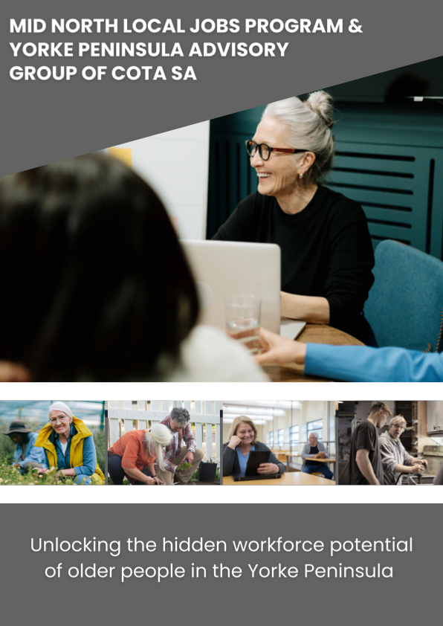



























Research into small business employment of mature age workers

**Appendix 5**

**Baseline and final surveys**

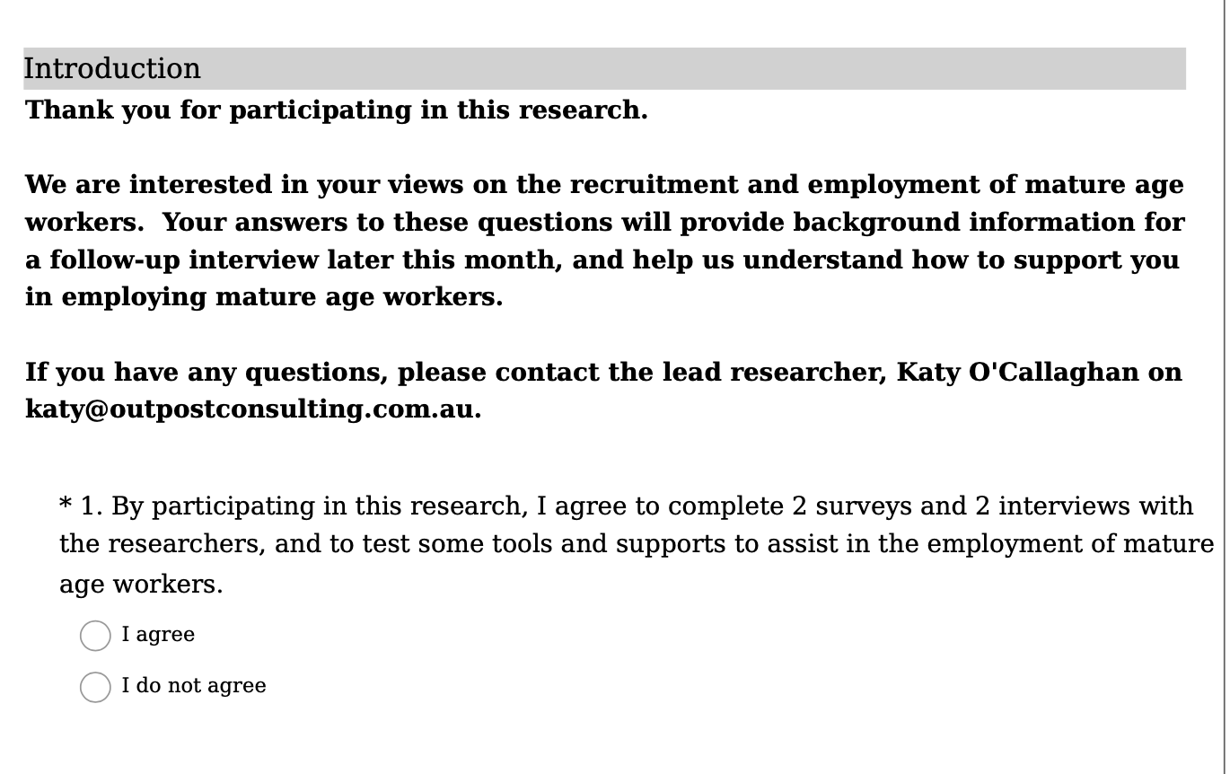

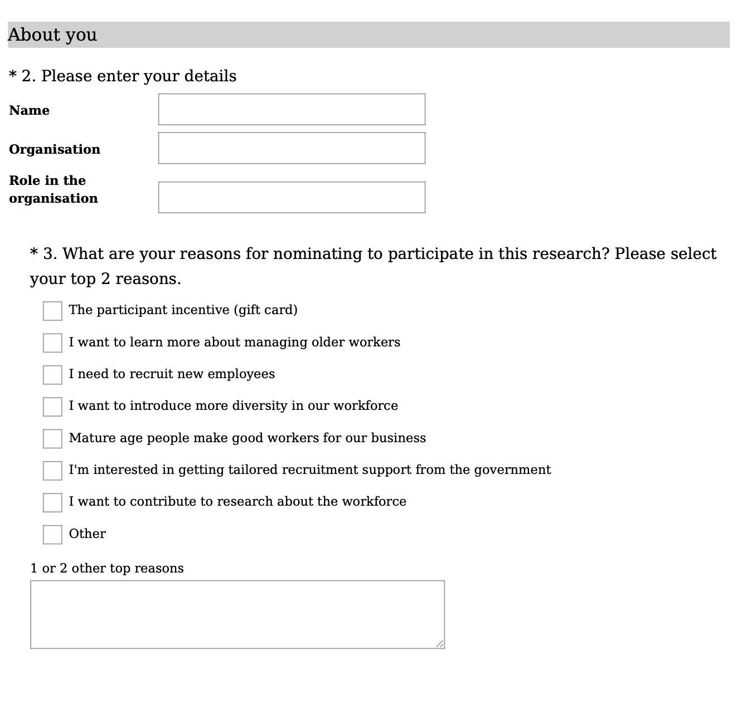

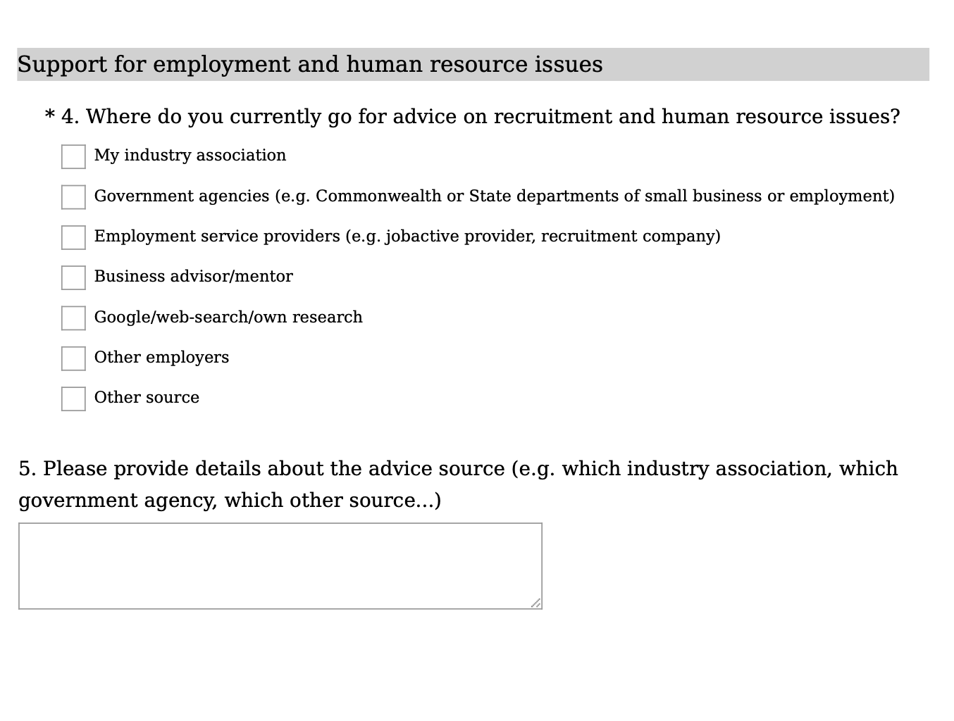 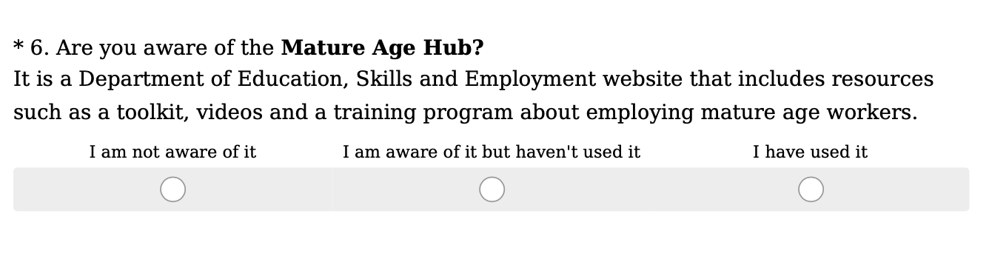

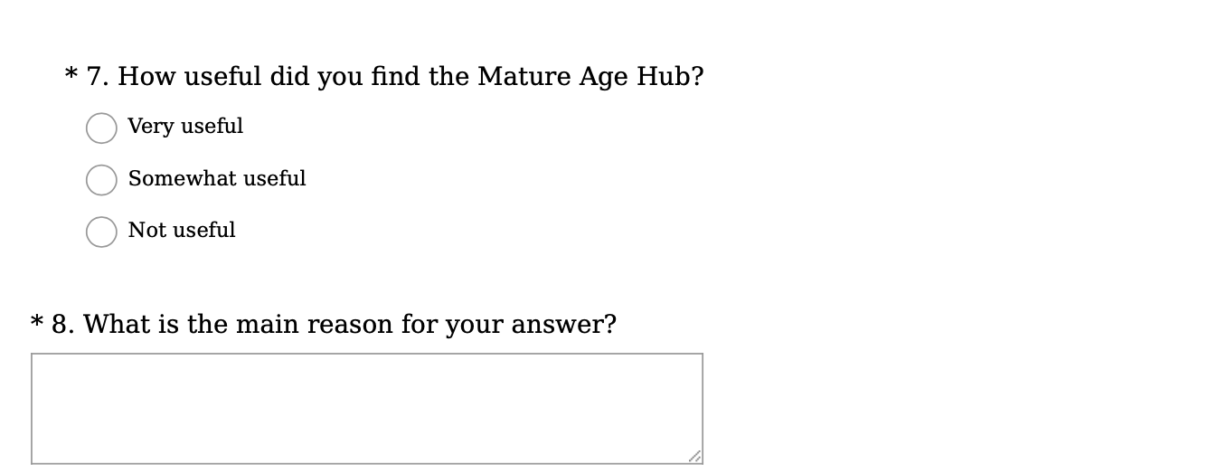

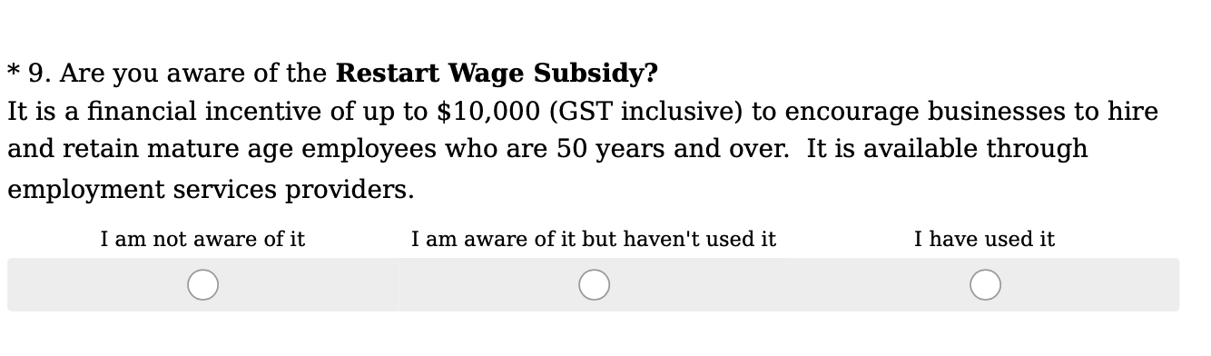

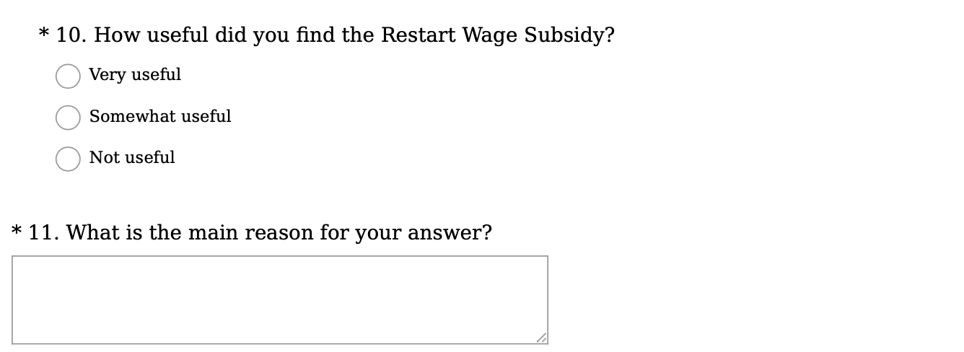

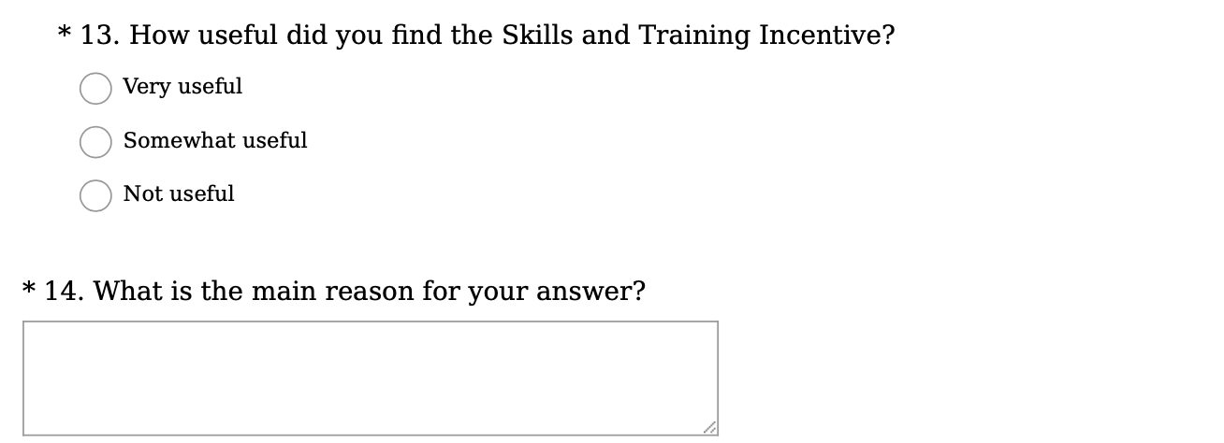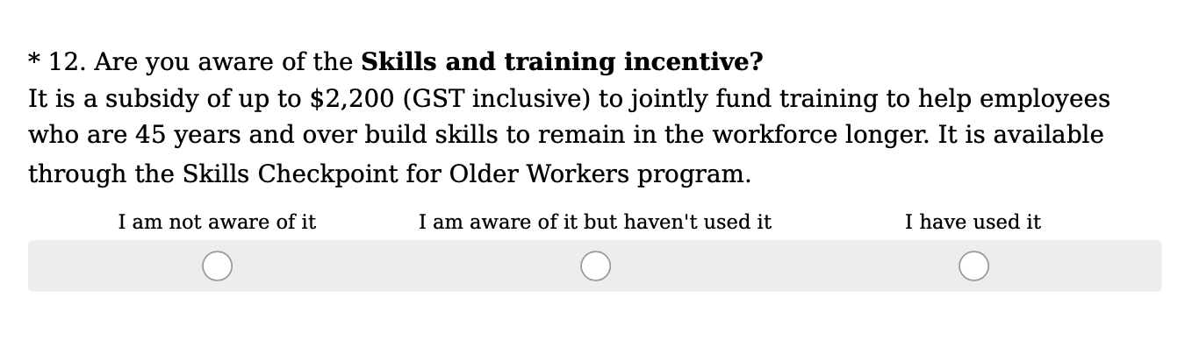

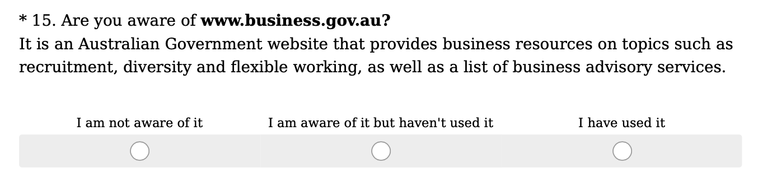

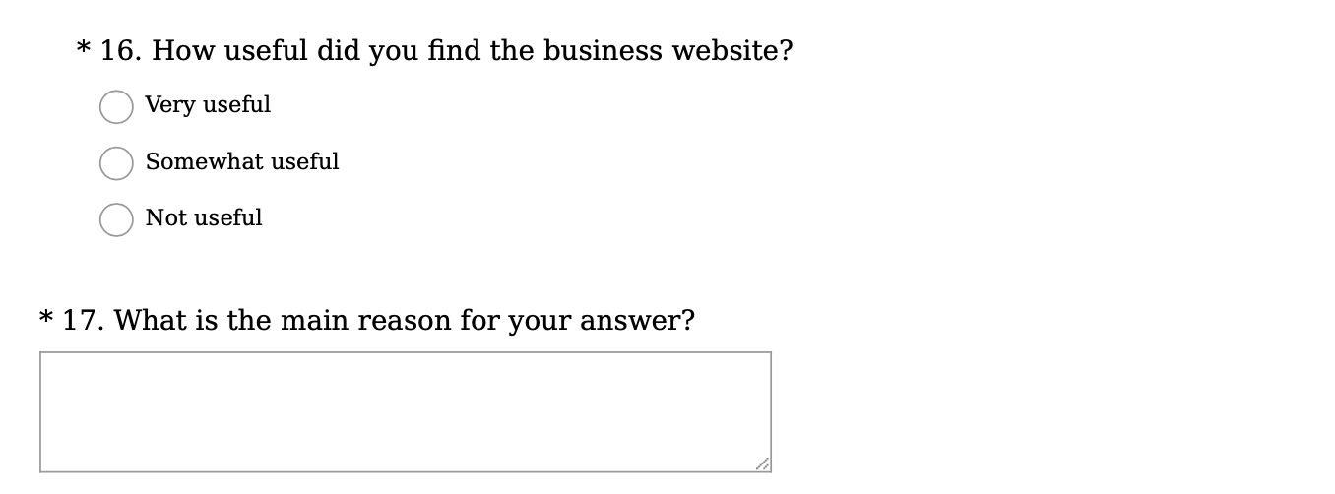

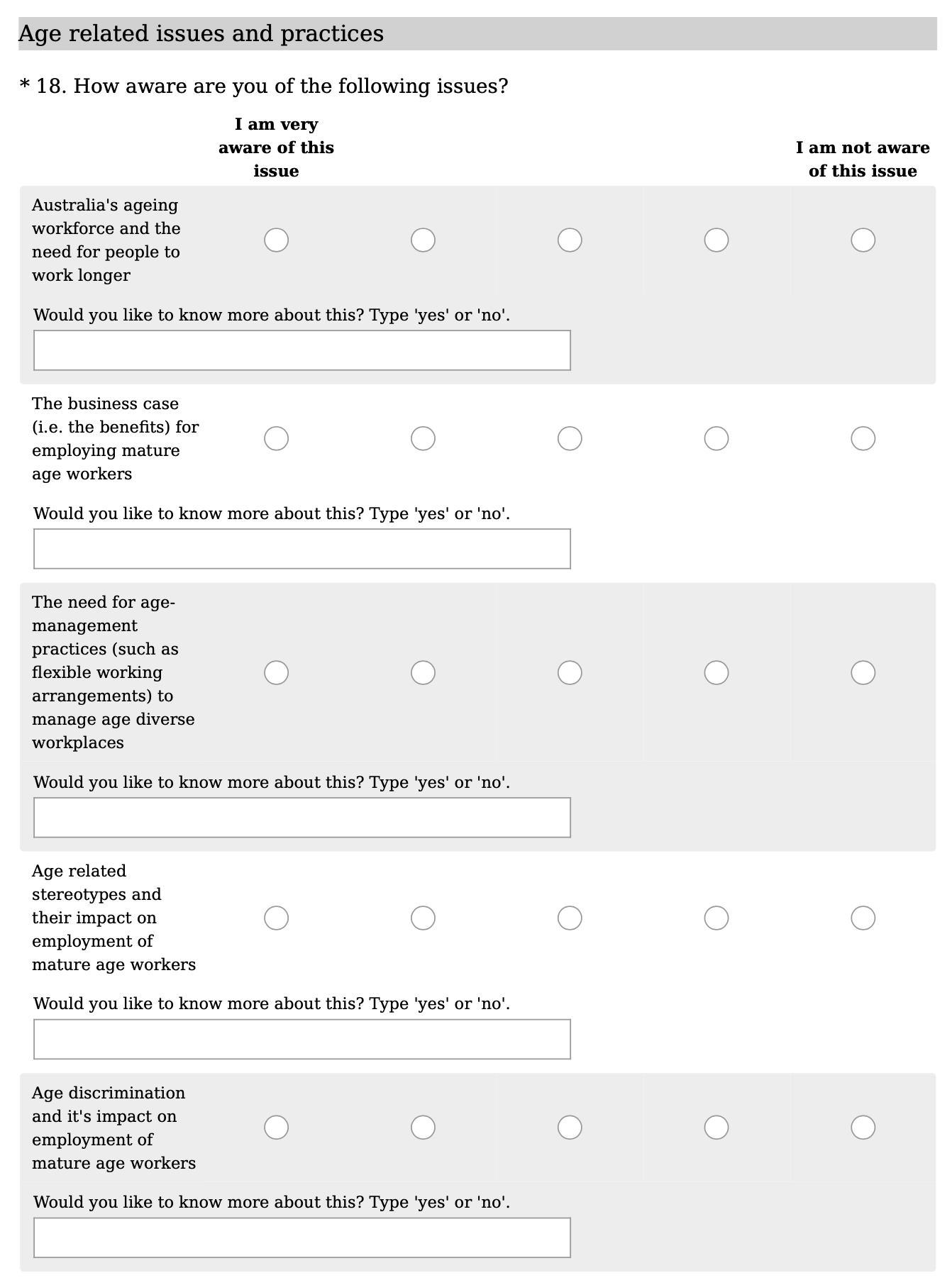

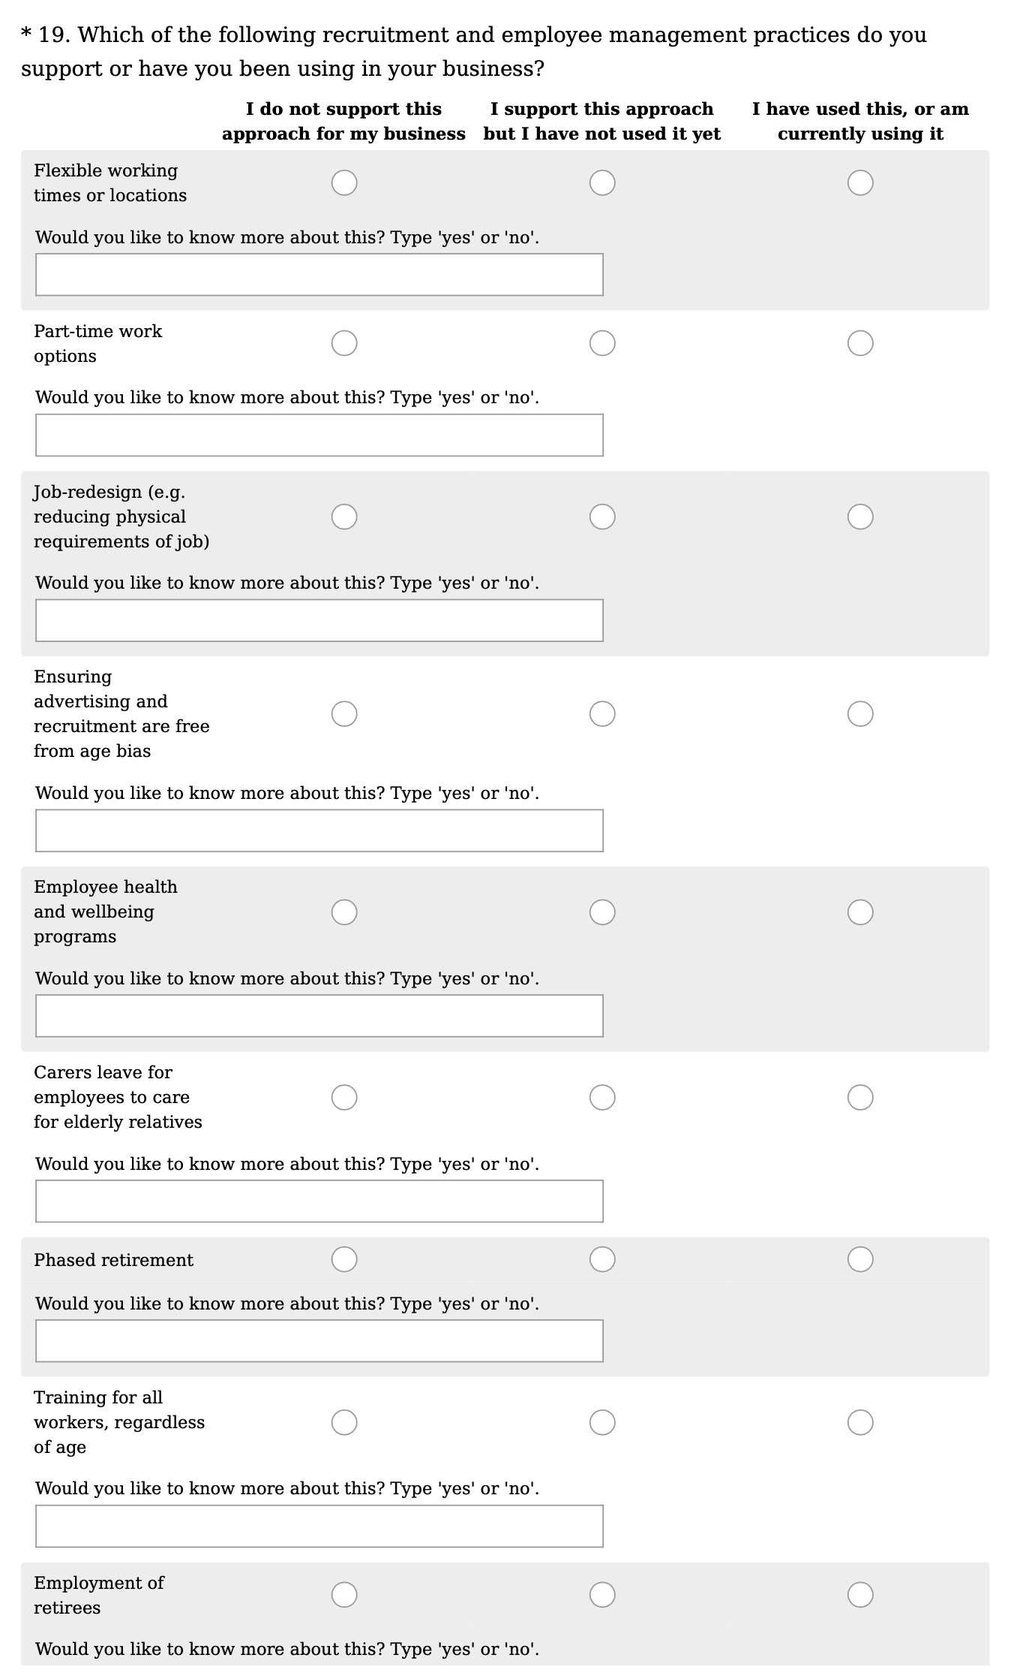

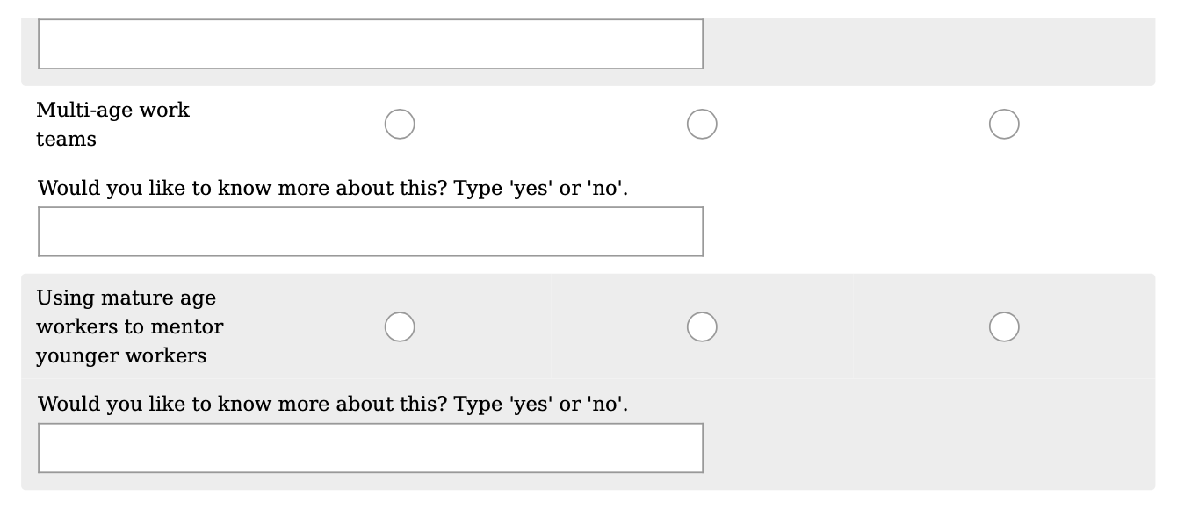

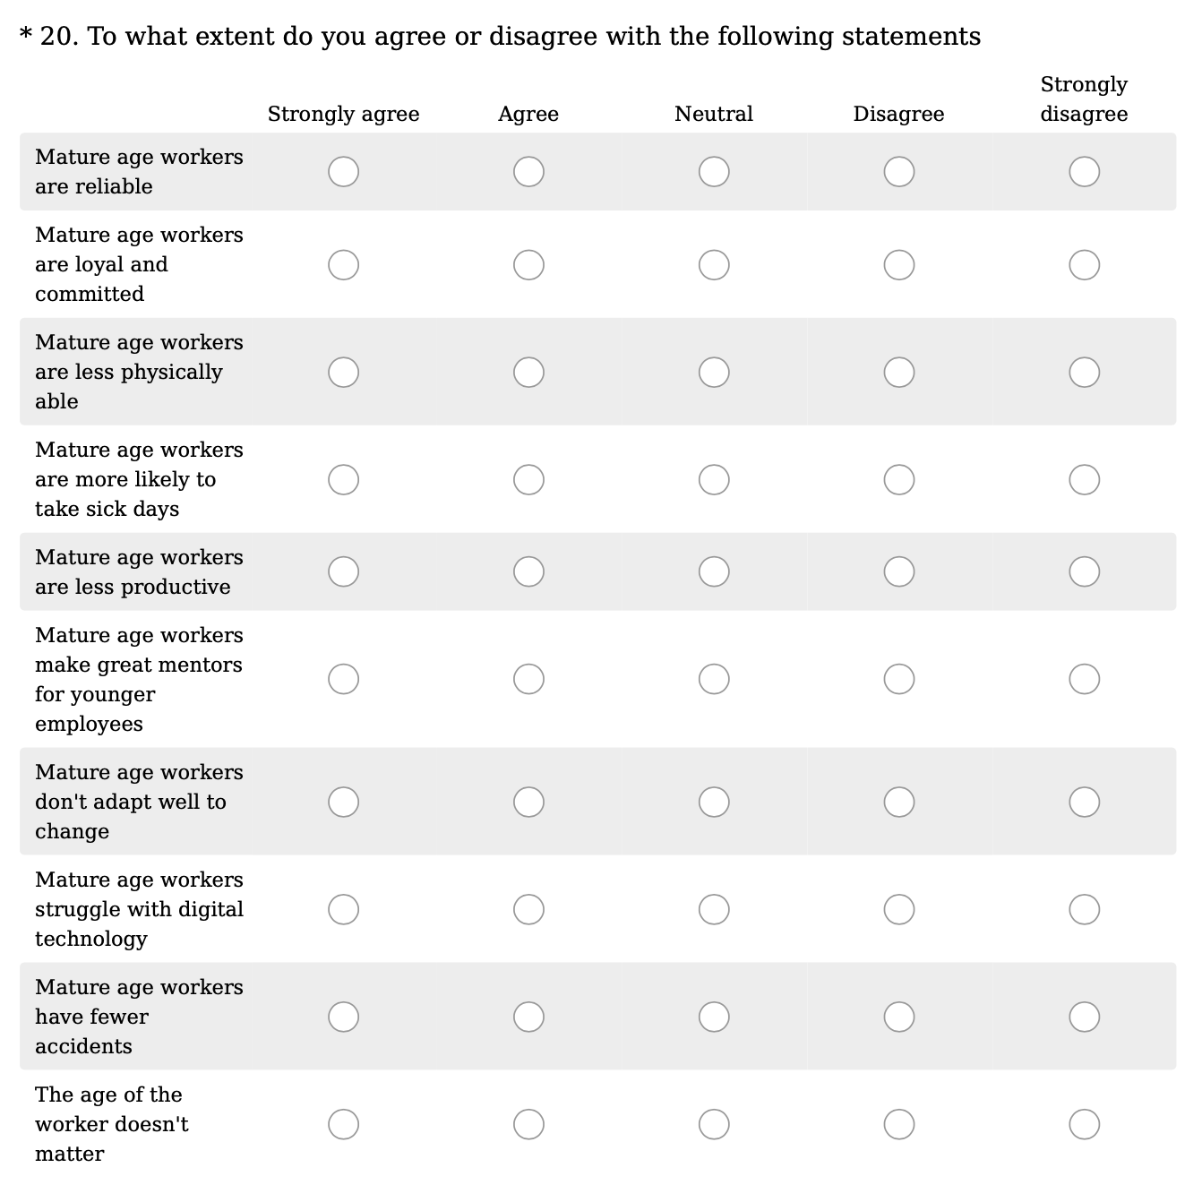

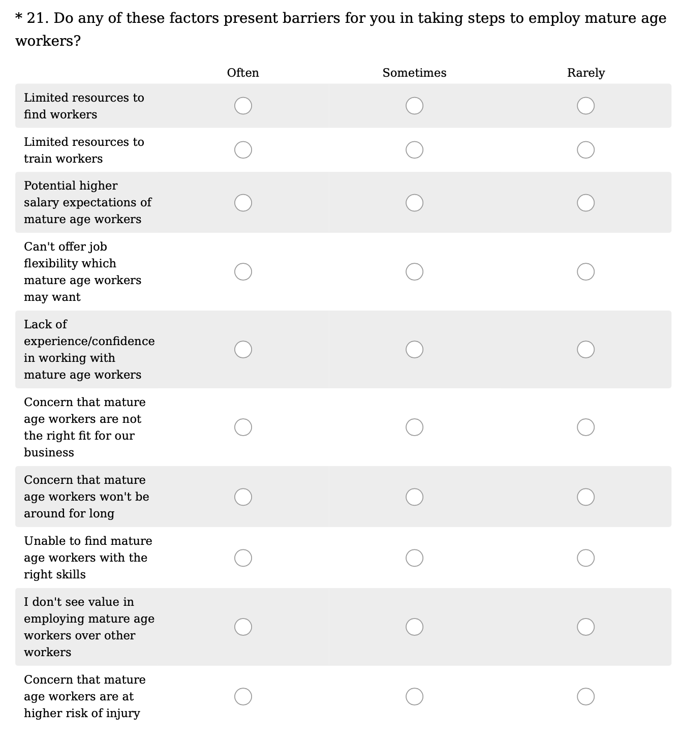

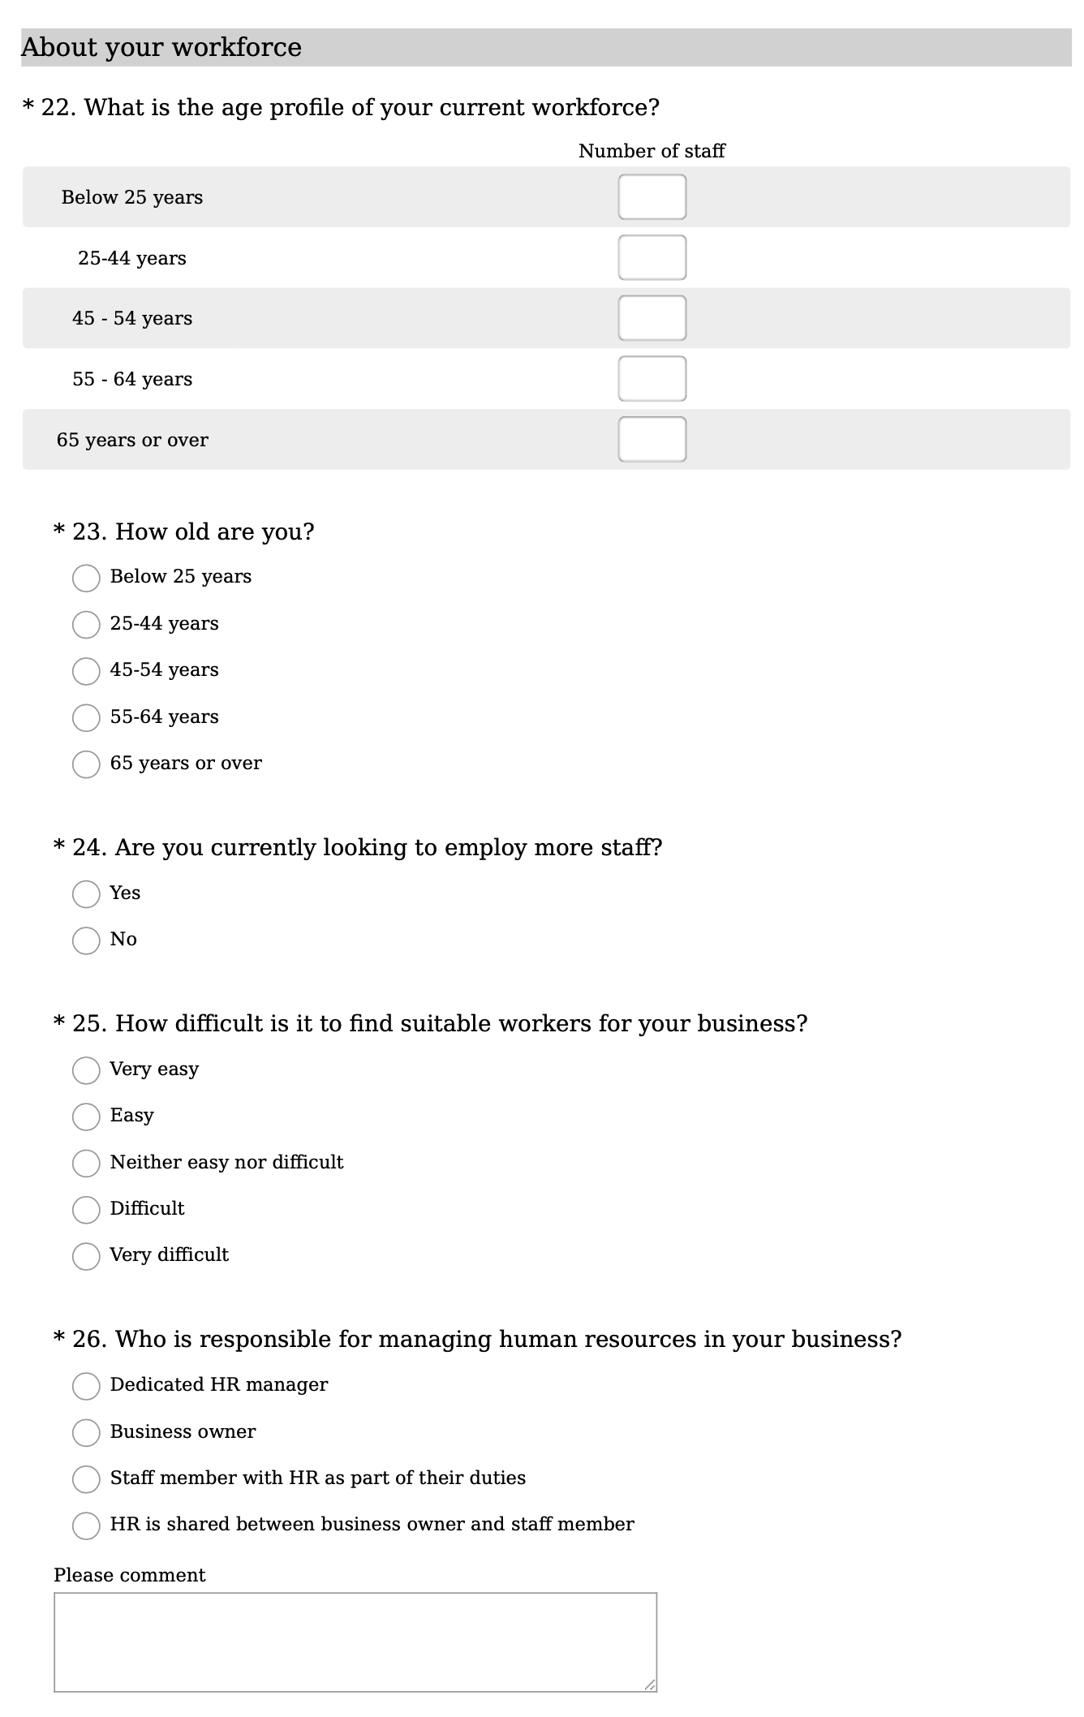

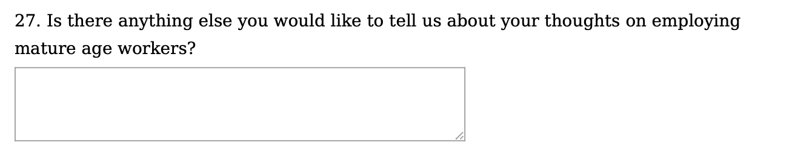

# 

# Appendix 6: Baseline and final interview guides

**Research on employment of mature age workers by small businesses – Discussion guide for businesses (baseline)**

# About the research

Outpost Consulting has been commissioned by the Department of Education, Skills and Employment to undertake research with a group of small businesses to understand issues related to the employment of mature age workers (over 55 years).

You have already completed an online survey providing some initial perspectives on opportunities and barriers for employment of mature age workers in your business.

In this follow-up interview we will seek to understand more about how mature age workers could fit into your business and what support might be useful to you in recruiting and retaining mature age workers.

If you have any questions, please contact your interviewer, **xxxx, on xxxx**.

# Questions for discussion

1. Can you tell me a little bit about the hiring practices you use in your business?
2. Have you used any specific strategies to recruit mature age workers? If so, tell me about what you’ve done. If not, is there a reason?
3. How do you/would you support mature age employees as they age in your business?
4. How do people in your organisation generally feel about older workers?
5. What challenges, if any, do you face in trying to attract and recruit mature age workers?
6. What challenges do you face in trying to retain mature age workers?
7. What challenges do you face in trying to manage an age-diverse workforce?
8. There are ***two types of resources*** we would like you to engage with over the next 8 weeks to tell us if they’ve been useful in:

* Teaching you something new
* Changing your outlook in relation to mature age workers
* Inspiring you to take steps to employ mature age workers.

The ***first*** is some written and online resources – a toolkit, a case study and some short online training modules. The ***second*** is receiving some tailored support around recruitment support and advice; training support and advice; and/or HR support and advice.

Are any of these of interest to you – or is there something else that might help with your employment of mature age workers?

**Research on employment of mature age workers by small businesses – Discussion guide for businesses (final)**

# Introduction

Thank you for participating in this research for the Department of Employment and Workplace Relations to help us to understand issues related to the employment of mature age workers by small businesses.

You have already completed the final online survey providing some initial feedback on the tools and support you engaged with to assist with the employment of mature age workers.

In this follow-up interview we will seek to understand more about what you thought of the assistance measures and if there has been any changes or outcomes since you engaged with them.

Following the interview we will send through a $1,000 gift voucher as an acknowledgement of the time and insights you have provided over the course of the project.

If you have any questions, please contact your interviewer, **xxx, on xxx**.

# Questions for discussion

1. Generally, how did you find the project? What were the things you liked and didn’t like about it? Did you get any outcomes?
2. Do you feel like your attitudes or the attitudes of your staff around employing mature age workers has changed? If so, how?
3. Do you feel like your knowledge about employing mature age workers has increased? What have you learnt?
4. Have the challenges you face in employing or retaining mature age workers changed? Did any of the assistance measures help you overcome those challenges? In what ways?
5. Now let’s talk about each of the tools you engaged with. What did you like and not like about each? Can you suggest any improvements or changes if they were to be used more widely?
   1. Good news stories
   2. Concise factual information
   3. Job matching websites
   4. DEWR Investing in Experience Toolkit
   5. DEWR Training Modules
6. Now let’s talk about the tailored support
   1. What steps did the employment facilitator take to assist you?
   2. Did the tailored support result in any employment outcomes or leads, or improvements in your business practices in relation to employing and retaining mature age workers?
   3. Is there anything that the employment facilitator could have done more of or differently?
7. Are you planning to take any further action in terms of employing or retaining mature age workers? What are you going to do next?
8. What would you like to tell the government about assisting small business to employ and retain mature age workers?

*Thanks again for contributing to this research*.

1. Australian HR Institute (2021) *Employing and retaining older workers*. Australian HR Institute and Australian Human Rights Commission. This was the latest version of this survey at the time of the literature review. For more recent data on employing and retaining older workers see www.ahri.com.au
2. Australian Human Rights Commission (2015) *National Prevalence Survey of Age Discrimination in the Workplace – 2015.* Australian Human Rights Commission, Sydney.
3. Egdell, V., Maclean, G., Raeside, R. & Chen, T. (2020) Age management in the workplace: manager and older worker accounts of policy andpractice. *Ageing & Society*, 40 (4), 784-804.
4. Garavaglia, E., Marcaletti, F. & Iñiguez-Berrozpe, T. (2021) Action Research in Age Management: The Quality of Ageing at Work Model, Work, Aging and Retirement, 7 (4), 339–351.
5. Egdell, V., Maclean, G., Raeside, R. & Chen, T. (2020) Age management in the workplace: manager and older worker accounts of policy andpractice. *Ageing & Society*, 40 (4), 784-804.
6. Atkinson, C. & Sandiford, P. (2016) An exploration of older worker flexible working arrangements in smaller firms**.** *Human Resource Management Journal*, 26, (1), 12–28.
7. Naegele, G. and Walker, A. (2006), A Guide to Good Practice in Age Management, European Foundation for the Improvement of Living and Working Conditions, Office for Official Publications of the European Communities, Luxembourg. p1-2
8. The Age and Employment Network (TAEN) (2007), Managing the Ageing Workforce: An Introductory Guide to Age Management for HR Professionals, TAEN, London.
9. Garavaglia, E., Marcaletti, F. & Iñiguez-Berrozpe, T. (2021) Action Research in Age Management: The Quality of Ageing at Work Model, Work, Aging and Retirement, 7 (4), 339–351.
10. Egdell, V., Maclean, G., Raeside, R. & Chen, T. (2020) Age management in the workplace: manager and older worker accounts of policy andpractice. *Ageing & Society*, 40 (4), 784-804.
11. Garavaglia, E., Marcaletti, F. & Iñiguez-Berrozpe, T. (2021) Action Research in Age Management: The Quality of Ageing at Work Model, Work, Aging and Retirement, 7 (4), 339–351.
12. OECD (2019) *Working Better with Age: Overview.* OECD Publishing, Paris.
13. Brussig, M. & Leber, U. (2019) After early retirement: the variety of human‑resource strategies of firmstowards older employees**.** *Journal for Labour Market Research*, 53:15
14. Brussig, M. & Leber, U. (2019) After early retirement: the variety of human‑resource strategies of firmstowards older employees**.** *Journal for Labour Market Research*, 53:15
15. Taylor, P., Earl, C. & McLoughlin, C. (2016), Recent public policy and Australian older workers*. Australian Journal of Social Issues*, 51, 229-247.
16. van Selm, M. & van den Heijkant, L. (2021) In Search of the Older Worker: Framing Job Requirements in Recruitment Advertisements. *Work, Aging and Retirement*, 7 (4), 288–302.
17. Egdell, V., Maclean, G., Raeside, R. & Chen, T. (2020) Age management in the workplace: manager and older worker accounts of policy andpractice. *Ageing & Society*, 40 (4), 784-804.
18. Atkinson, C. & Sandiford, P. (2016) An exploration of older worker flexible working arrangements in smaller firms**.** *Human Resource Management Journal*, 26, (1), 12–28.
19. OECD (2019) *Working Better with Age: Overview.* OECD Publishing, Paris.
20. Blomé, M., Borell, J., Håkansson, C. & Kerstin Nilsson (2020) Attitudes toward elderly workers and perceptions of integrated age management practices. *International Journal of Occupational Safety and Ergonomics*, 26 (1), 112-120.
21. Brussig, M. & Leber, U. (2019) After early retirement: the variety of human‑resource strategies of firmstowards older employees**.** *Journal for Labour Market Research*, 53:15
22. Fuertes, V., Egdell, V. & McQuaid, R. (2013), Extending working lives: age management in SMEs, *Employee Relations*, 35 (3), 272-293.
23. Atkinson, C. & Sandiford, P. (2016) An exploration of older worker flexible working arrangements in smaller firms**.** *Human Resource Management Journal*, 26, (1), 12–28.
24. Tunney, O. & Mulders, J.O. (2022) When and Why Do Employers (Re)Hire Employees Beyond Normal Retirement Age? *Work, Aging and Retirement*, 8 (1), 25–37.
25. Egdell, V., Maclean, G., Raeside, R. & Chen, T. (2020) Age management in the workplace: manager and older worker accounts of policy andpractice. *Ageing & Society*, 40 (4), 784-804.
26. Atkinson, C. & Sandiford, P. (2016) An exploration of older worker flexible working arrangements in smaller firms**.** *Human Resource Management Journal*, 26, (1), 12–28.
27. Fuertes, V., Egdell, V. & McQuaid, R. (2013), Extending working lives: age management in SMEs, *Employee Relations*, 35 (3), 272-293.
28. Australian Human Rights Commission (2016)*Willing to Work: National Inquiry into Employment Discrimination Against Older Australians and Australians with Disability.* Australian Human Rights Commission, Sydney.
29. Australian Human Rights Commission (2016)*Willing to Work: National Inquiry into Employment Discrimination Against Older Australians and Australians with Disability.* Australian Human Rights Commission, Sydney. p136
30. Fuertes, V., Egdell, V. & McQuaid, R. (2013), Extending working lives: age management in SMEs, *Employee Relations*, 35 (3), 272-293.
31. OECD (2019) *Working Better with Age: Overview.* OECD Publishing, Paris.
32. Fuertes, V., Egdell, V. & McQuaid, R. (2013), Extending working lives: age management in SMEs, *Employee Relations*, 35 (3), 272-293.
33. Fuertes, V., Egdell, V. & McQuaid, R. (2013), Extending working lives: age management in SMEs, *Employee Relations*, 35 (3), 272-293.
34. OECD (2019) *Working Better with Age: Overview.* OECD Publishing, Paris.
35. Fuertes, V., Egdell, V. & McQuaid, R. (2013), Extending working lives: age management in SMEs, *Employee Relations*, 35 (3), 272-293.
36. Trochimiuk, R. (2015) Professional Development of Older Employeesin Small and Medium Enterprises**.** *Management and Business Administration. Central Europe*, 23 (1), 79–94.
37. Kulik, C., Perera, S., Cregan, C. (2016) Engage Me: The Mature-Age Worker and Stereotype Threat. *Academy of Management Journal*. 2016; 59 (6):2132-2156
38. Gellert, F. J., & Kuipers, B. S. (2008). Short- and long-term consequences of age in work teams: An empirical exploration of ageing teams. *Career Development International*, 13(2), 132–149
39. Patrickson, M., & Ranzijn, R. (2004). Bounded choices in work and retirement in Australia. *Employee Relations*, 26(4), 422–432
40. Australian HR Institute (2021) *Employing and retaining older workers*. Australian HR Institute and Australian Human Rights Commission
41. Department of Employment, Skills and Family Business (2020) Employers’ experiences and attitudes to hiring mature age workers
42. Fuertes, V., Egdell, V. & McQuaid, R. (2013), Extending working lives: age management in SMEs, *Employee Relations*, 35 (3), 272-293.
43. Murphy, K. & DeNisi, A. (2021) Do Age Stereotypes Predict Personnel Decisions? The State of the Evidence, Work, Aging and Retirement, waab019.
44. Radford, K., Chapman, G., Bainbridge, H. T. J., & Halvorsen, B. (2018) The ageing population in Australia: Implications for the workforce. In S. Werth, & C. Brownlow (Eds.), *Work and Identity: Contemporary Perspectives on Workplace Diversity* (pp. 39- 54)
45. Murphy, K. & DeNisi, A. (2021) Do Age Stereotypes Predict Personnel Decisions? The State of the Evidence, Work, Aging and Retirement, waab019.
46. Fuertes, V., Egdell, V. & McQuaid, R. (2013), Extending working lives: age management in SMEs, *Employee Relations*, 35 (3), 272-293.
47. Taylor, P., & Earl, C. (2021). The enduring myth of endemic age discrimination in the Australian labour market. *Ageing and Society*, 1-10.
48. Egdell, V., Maclean, G., Raeside, R. & Chen, T. (2020) Age management in the workplace: manager and older worker accounts of policy andpractice. *Ageing & Society*, 40 (4), 784-804.
49. Egdell, V., Maclean, G., Raeside, R. & Chen, T. (2020) Age management in the workplace: manager and older worker accounts of policy andpractice. *Ageing & Society*, 40 (4), 784-804.
50. Fasbender, U. & Wang, M. (2017) Intergenerational contact and hiring decisions about older workers. *Frontiers in Psychology,* 7, 2057.
51. Garavaglia, E., Marcaletti, F. & Iñiguez-Berrozpe, T. (2021) Action Research in Age Management: The Quality of Ageing at Work Model, Work, Aging and Retirement, 7 (4), 339–351.
52. Fuertes, V., Egdell, V. & McQuaid, R. (2013), Extending working lives: age management in SMEs, *Employee Relations*, 35 (3), 272-293.
53. Fuertes, V., Egdell, V. & McQuaid, R. (2013), Extending working lives: age management in SMEs, *Employee Relations*, 35 (3), 272-293.
54. van Selm, M. & van den Heijkant, L. (2021) In Search of the Older Worker: Framing Job Requirements in Recruitment Advertisements. *Work, Aging and Retirement*, 7 (4), 288–302.
55. EU-OSHA, Cedefop, Eurofound and EIGE (2017) *Joint report on Towards age-friendly work in Europe: a life-course perspective on work and ageing from EU Agencies*, Publications Office of the European Union, Luxembourg
56. Brussig, M. & Leber, U. (2019) After early retirement: the variety of human‑resource strategies of firmstowards older employees**.** *Journal for Labour Market Research*, 53:15
57. Garavaglia, E., Marcaletti, F. & Iñiguez-Berrozpe, T. (2021) Action Research in Age Management: The Quality of Ageing at Work Model, Work, Aging and Retirement, 7 (4), 339–351.
58. OECD (2019) *Working Better with Age: Overview.* OECD Publishing, Paris.
59. Brussig, M. & Leber, U. (2019) After early retirement: the variety of human‑resource strategies of firmstowards older employees**.** *Journal for Labour Market Research*, 53:15
60. Australian Human Rights Commission (2016)*Willing to Work:* *National Inquiry into Employment Discrimination Against Older Australians and Australians with Disability.* Australian Human Rights Commission, Sydney.
61. Boehm, S., Schröder, H. & Bal, H. (2021) Age-Related Human Resource Management Policies and Practices: Antecedents, Outcomes, and Conceptualizations. *Work, Aging and Retirement*, 7 (4), 257–272.
62. Fuertes, V., Egdell, V. & McQuaid, R. (2013), Extending working lives: age management in SMEs, *Employee Relations*, 35 (3), 272-293.
63. Urbancova, H. & Hudakova, M. (2015) Employee Development in Small and MediumEnterprises in the Light of Demographic Evolution. *Acta Universitatis Agriculturae et Silviculturae**Mendelianae Brunensis*, 63(3), 1043–1050.
64. Boehm, S., Schröder, H. & Bal, H. (2021) Age-Related Human Resource Management Policies and Practices: Antecedents, Outcomes, and Conceptualizations. *Work, Aging and Retirement*, 7 (4), 257–272.
65. Garavaglia, E., Marcaletti, F. & Iñiguez-Berrozpe, T. (2021) Action Research in Age Management: The Quality of Ageing at Work Model, Work, Aging and Retirement, 7 (4), 339–351.
66. Egdell, V., Maclean, G., Raeside, R. & Chen, T. (2020) Age management in the workplace: manager and older worker accounts of policy andpractice. *Ageing & Society*, 40 (4), 784-804.
67. Boehm, S., Schröder, H. & Bal, H. (2021) Age-Related Human Resource Management Policies and Practices: Antecedents, Outcomes, and Conceptualizations. *Work, Aging and Retirement*, 7 (4), 257–272.
68. Blomé, M., Borell, J., Håkansson, C. & Kerstin Nilsson (2020) Attitudes toward elderly workers and perceptions of integrated age management practices. *International Journal of Occupational Safety and Ergonomics*, 26 (1), 112-120.
69. Garavaglia, E., Marcaletti, F. & Iñiguez-Berrozpe, T. (2021) Action Research in Age Management: The Quality of Ageing at Work Model, Work, Aging and Retirement, 7 (4), 339–351.
70. Fekke Ybema, J., van Vuuren, T. & van Dam, K. (2020) HR practices for enhancing sustainable employability: implementation, use, and outcomes. *The International Journal of Human Resource Management*, 31 (7), 886-907.
71. Fuertes, V., Egdell, V. & McQuaid, R. (2013), Extending working lives: age management in SMEs, *Employee Relations*, 35 (3), 272-293.
72. Atkinson, C. & Sandiford, P. (2016) An exploration of older worker flexible working arrangements in smaller firms**.** *Human Resource Management Journal*, 26, (1), 12–28.
73. Moen, P, Kojola E. and Schaefers, K. (2017) Organizational Change Around an Older Workforce. *Gerontologist*, 57 (5), 847–856.
74. Moen, P, Kojola E. and Schaefers, K. (2017) Organizational Change Around an Older Workforce. *Gerontologist*, 57 (5), 847–856.
75. Outpost Consulting (2021) *Research into employment barriers for mature age Australians.* Published online at <https://www.dese.gov.au/mature-age-hub/resources/employment-barriers-mature-age-australians-research-project> .